**PDA:** **Software** **Development Level** **8**

**Student:** David Sanchez Rodriguez

**EVIDENCE:** UNIT P

**Ref:** P5

* Create a user sitemap



**Ref:** P6

* Produce two wireframe designs





**Ref:** P10

* Example of pseudocode for a function

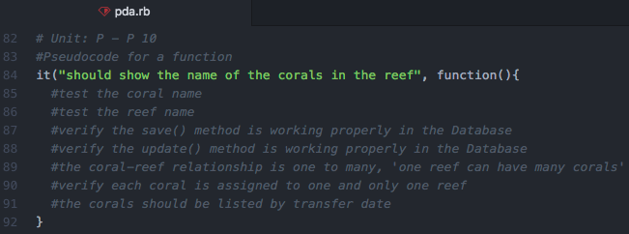

**Ref:** P13

* **The user inputting something into your program (Updating data)**

1. The user wants to change the plant date for the coral at the bottom of the table (Acropora cervicornus) from “2012 – 11 – 14” to “2012 – 11 – 16” by clicking the button Edit Coral Information

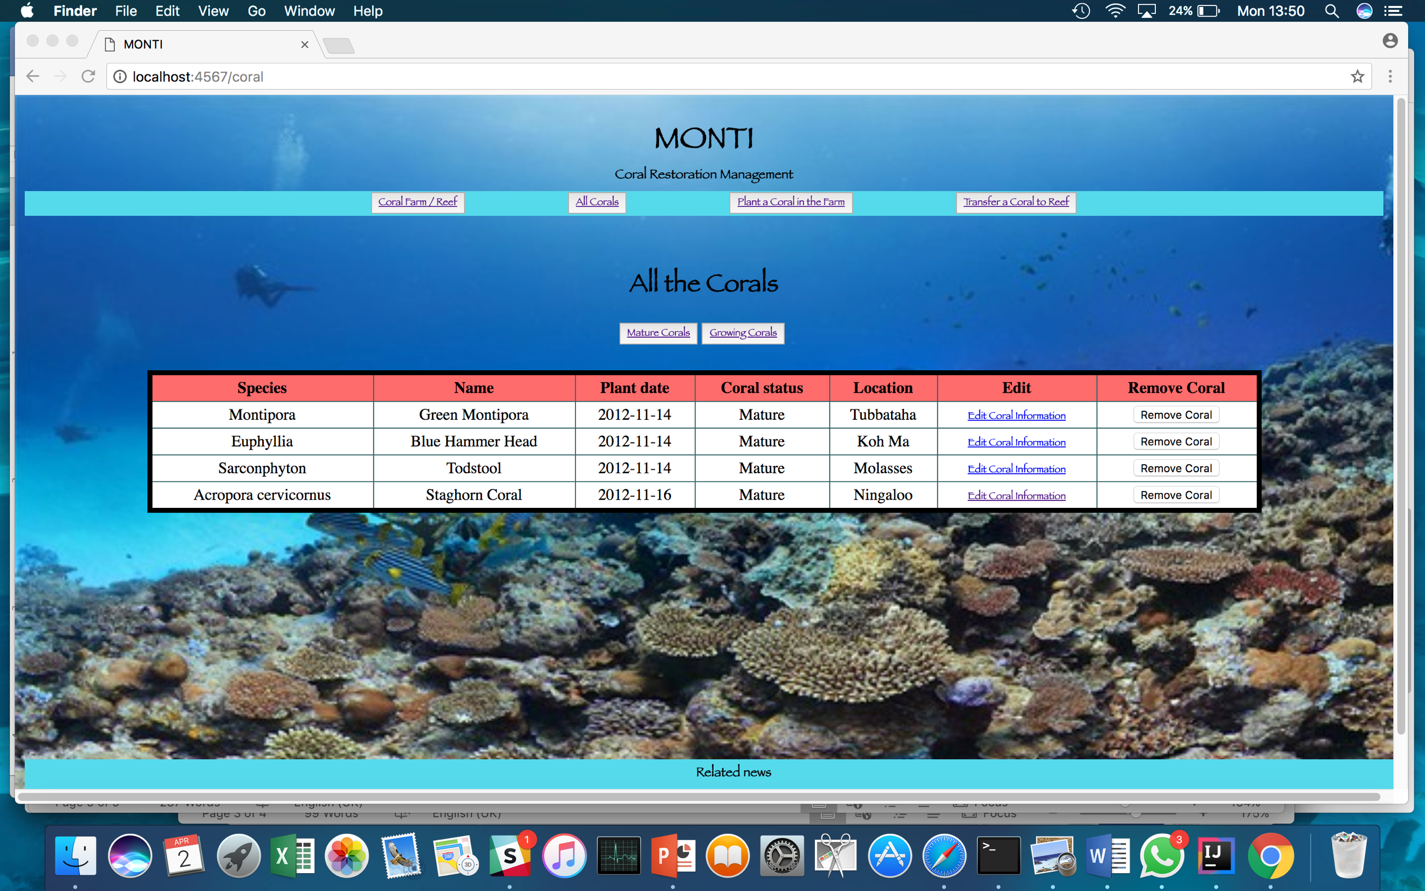

1. Once the Edit Coral Information is clicked the user is sent to the website view for editing coral information

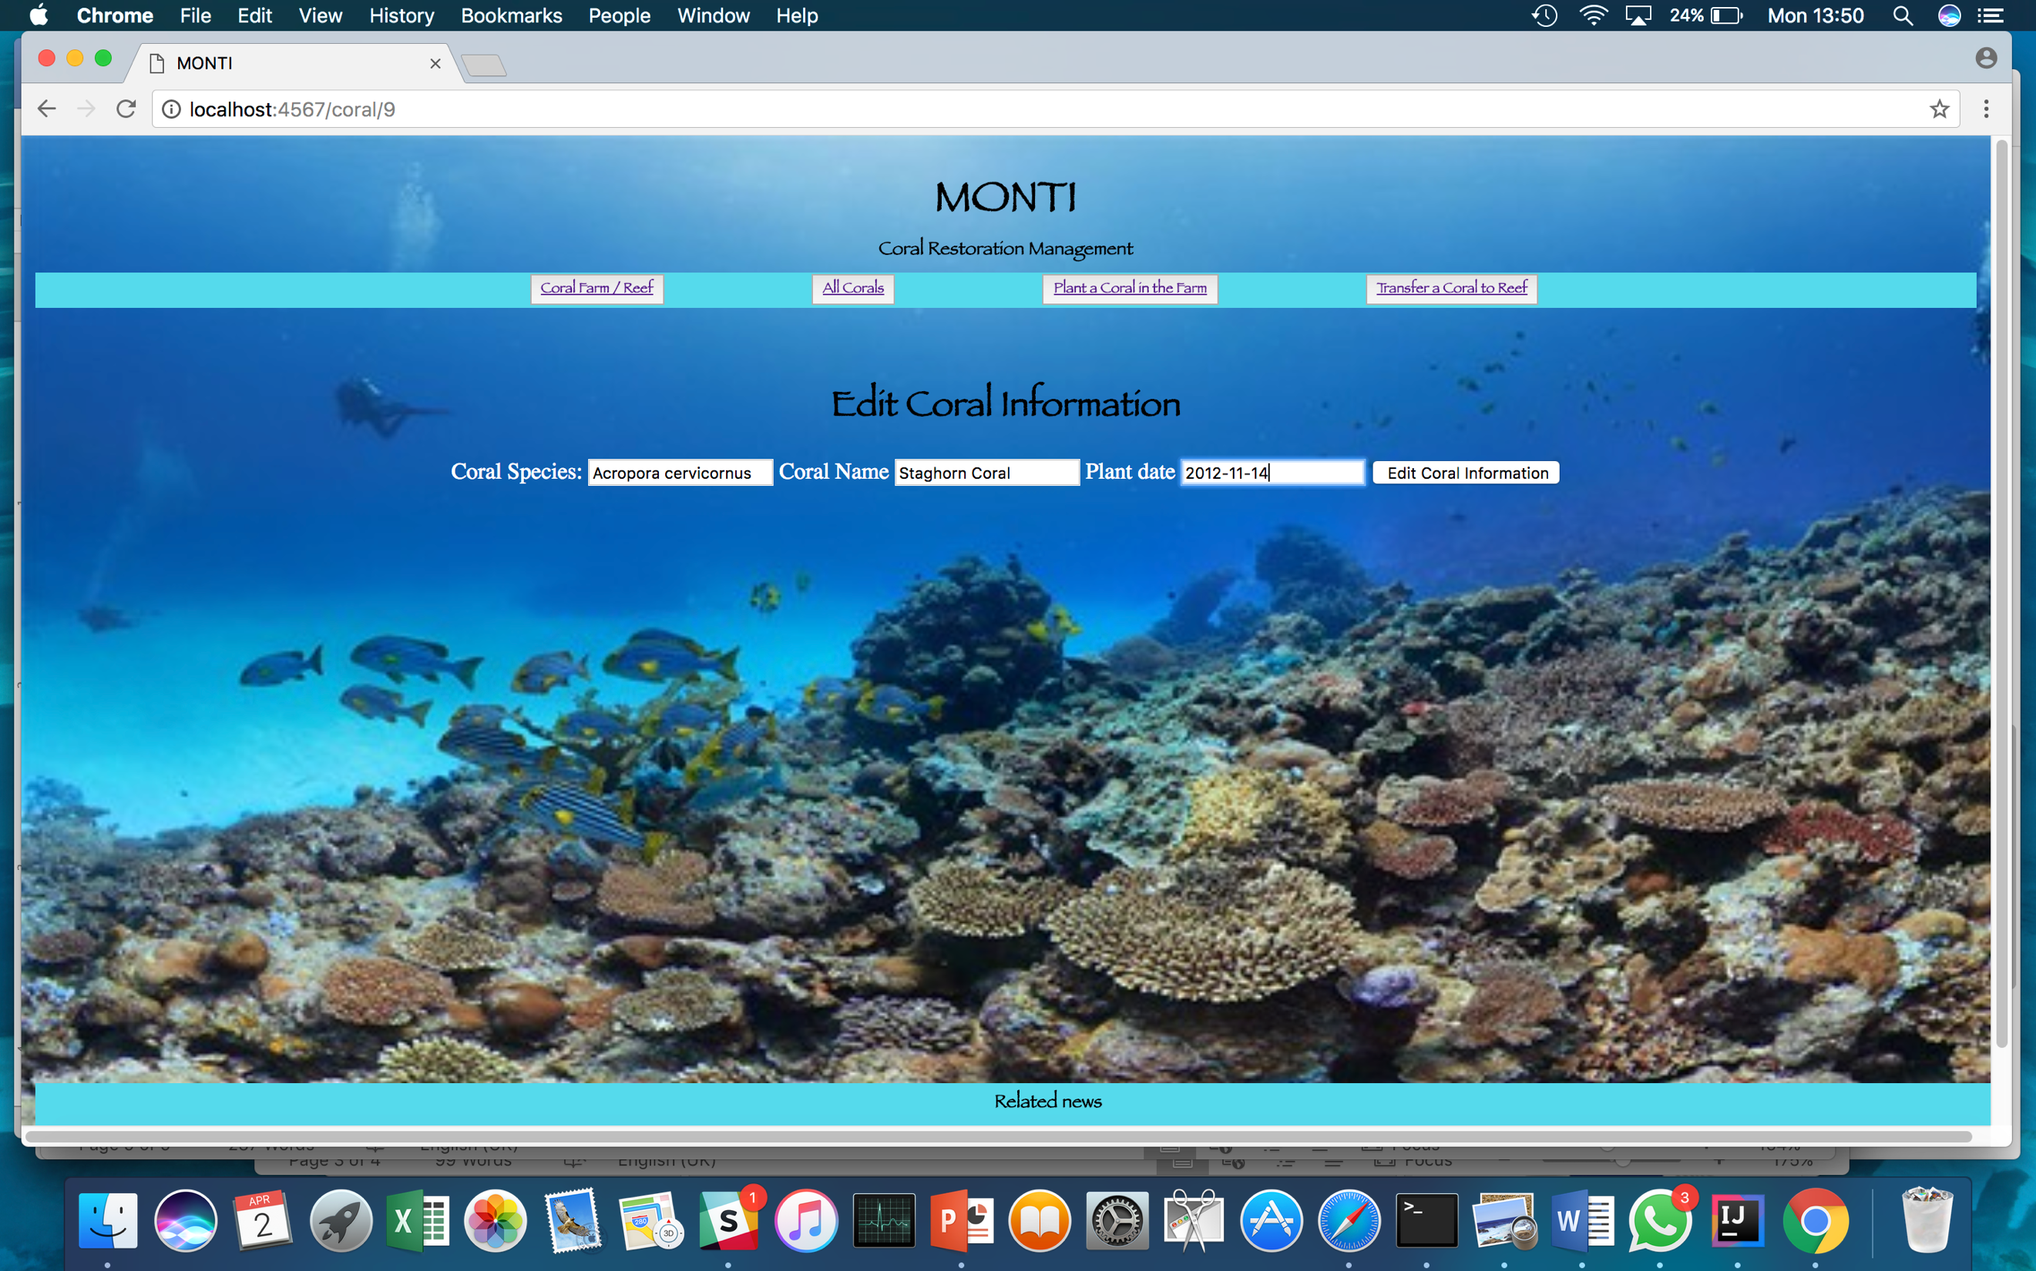

1. Once the information is edited, the coral at the bottom of the table appears with the new plant date.

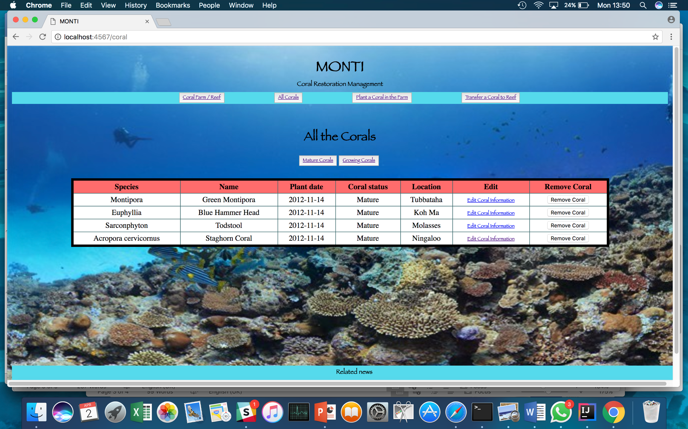

**Ref:** P14

* **Show an interaction with data persistence (Adding new data).**

1. The user selecting the Coral Species using the drop-down menu.

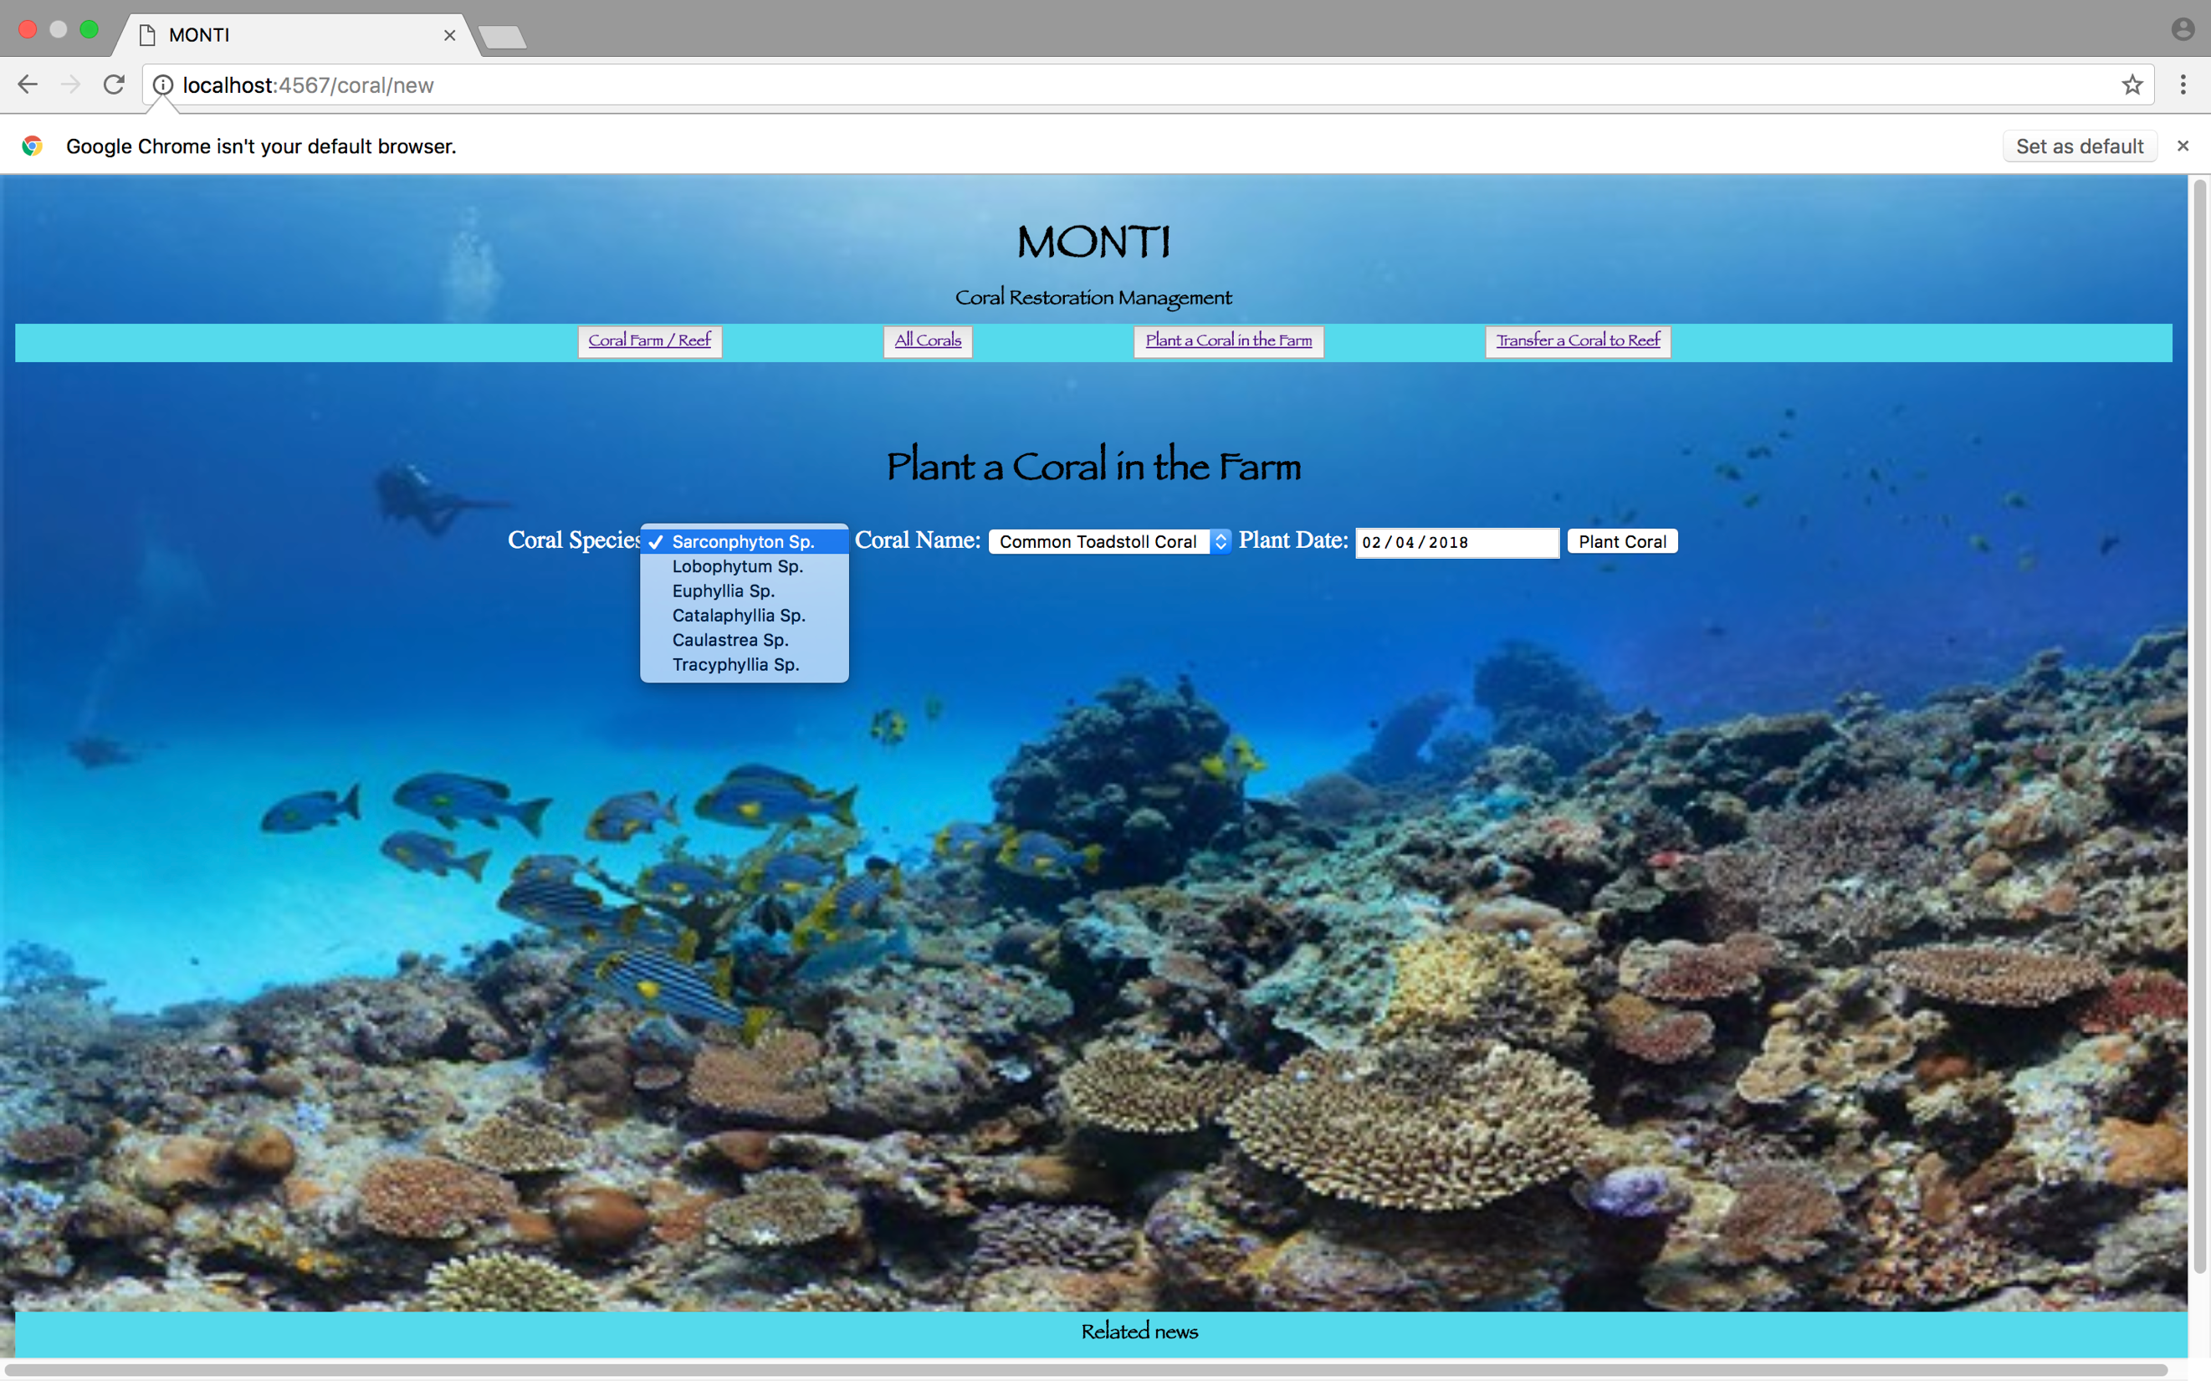

1. The user selecting the Coral Name using the drop-down menu.

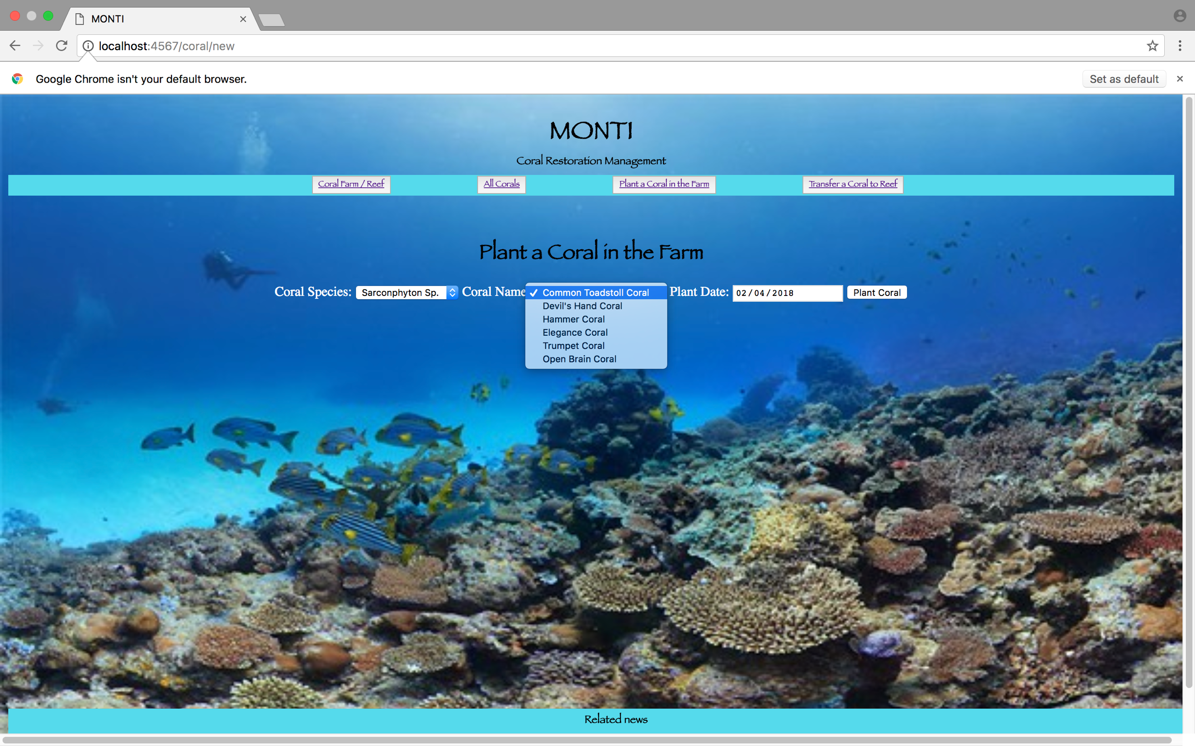

1. The user selecting the Date the coral was planted.

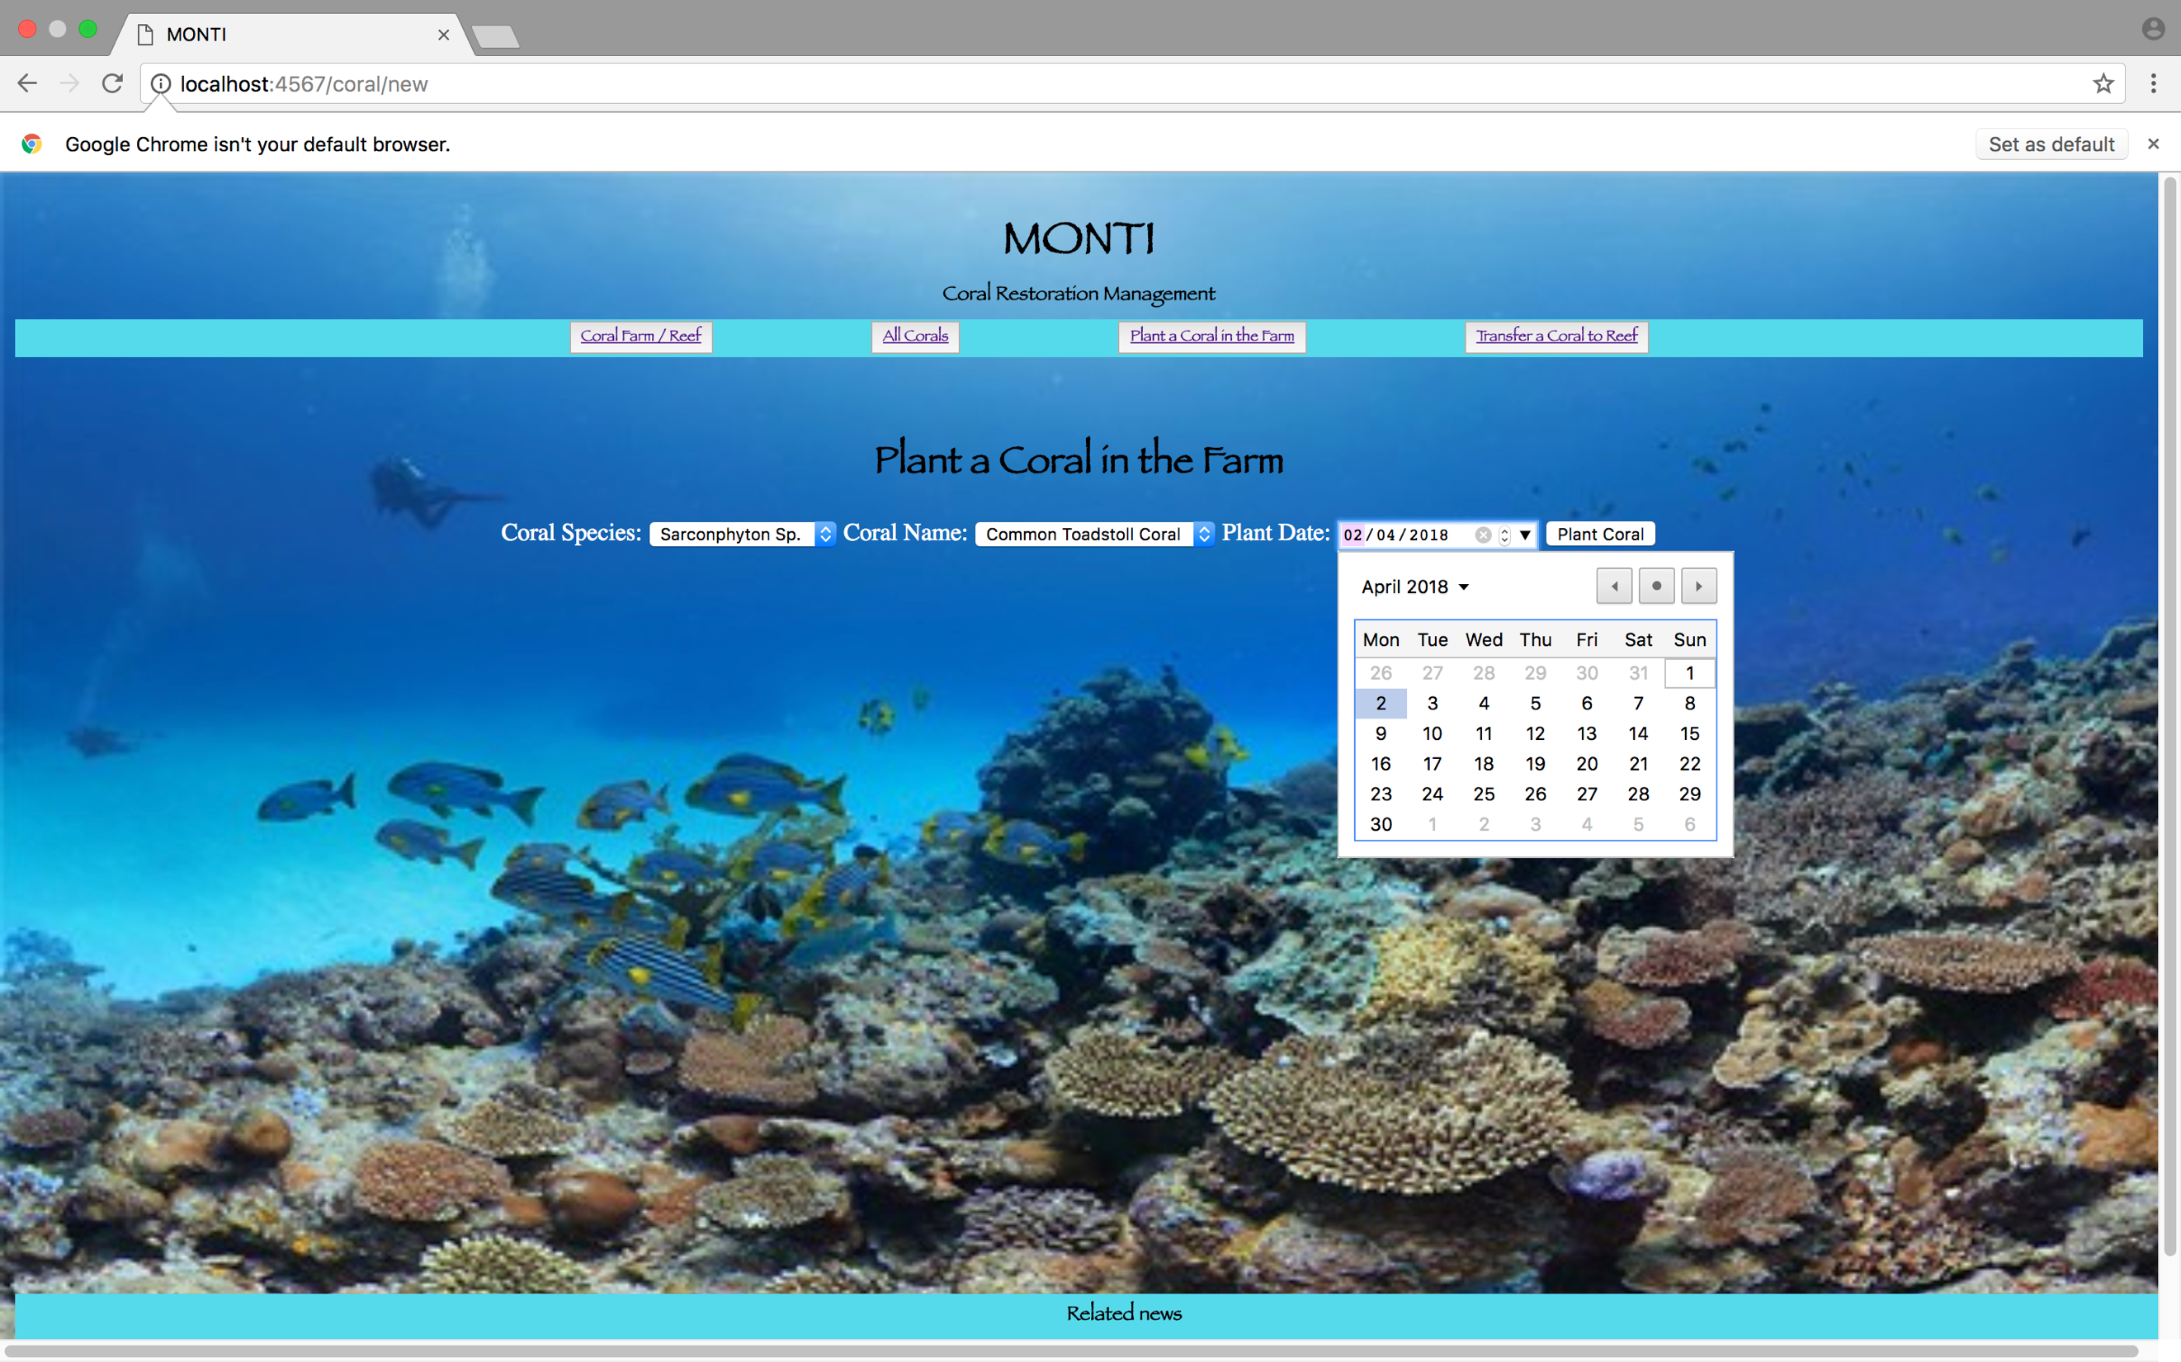

1. Before adding the coral, the “All the Corals” have 5 corals in it.

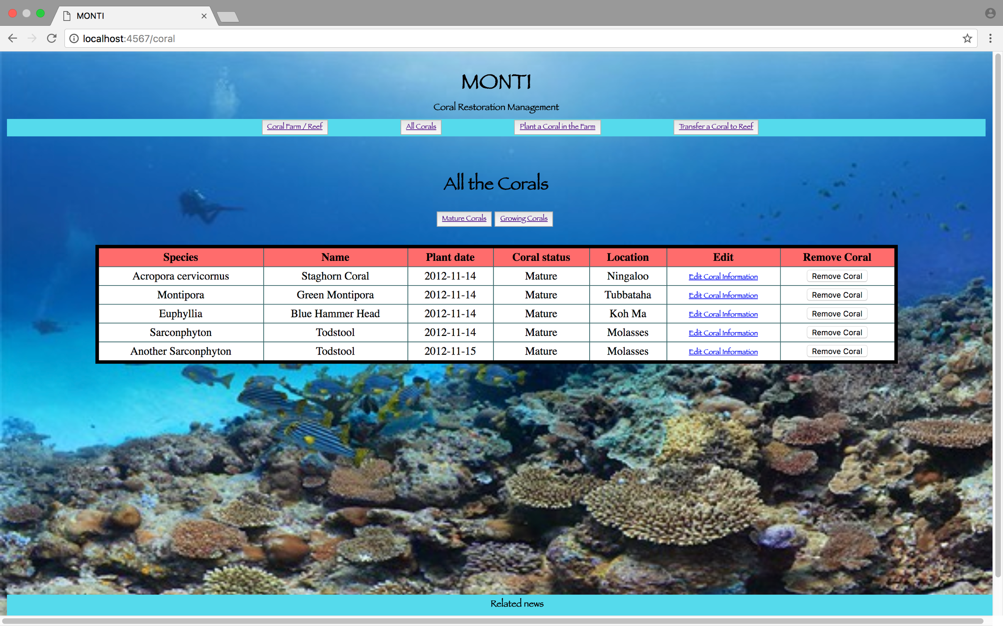

1. After adding the coral, the “All the Corals” have 6 corals in it.

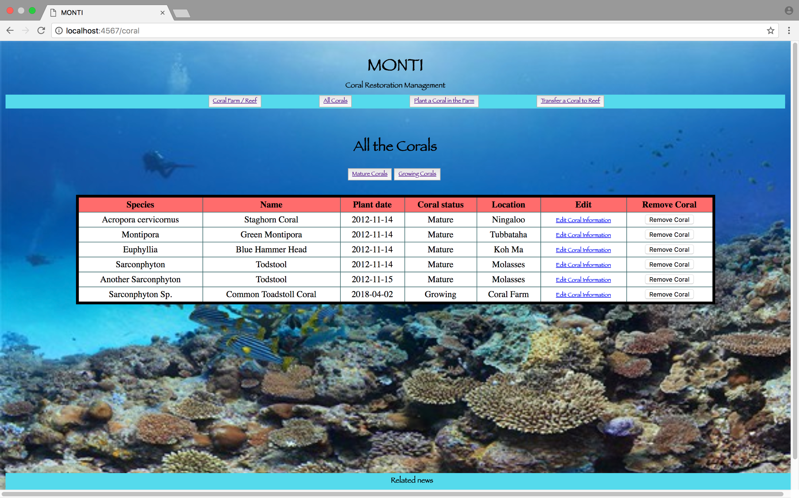

**Ref:** P15

* Show the correct output of results and feedback to user:

1. The user requesting information or an action to be performed:

The request is to see all the corals in Ningaloo, Australia

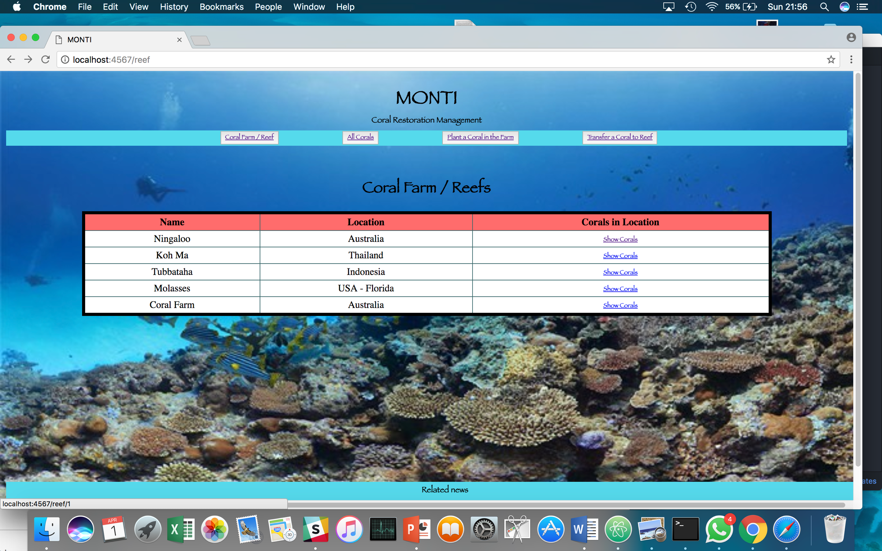

1. The user request being processed correctly and demonstrated in the program:

The result of the request the 2 corals currently present in Ningaloo, Australia.

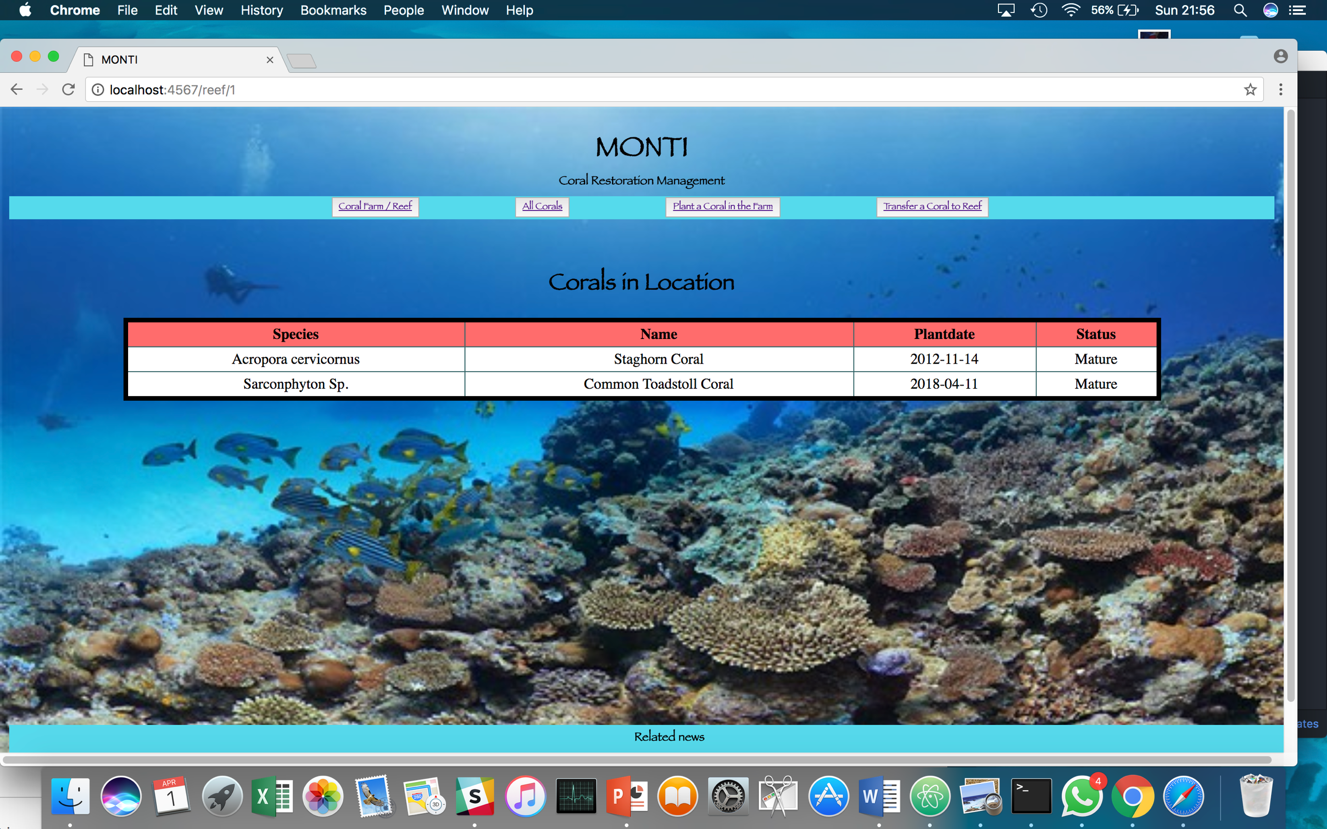

**Ref:** P11

* 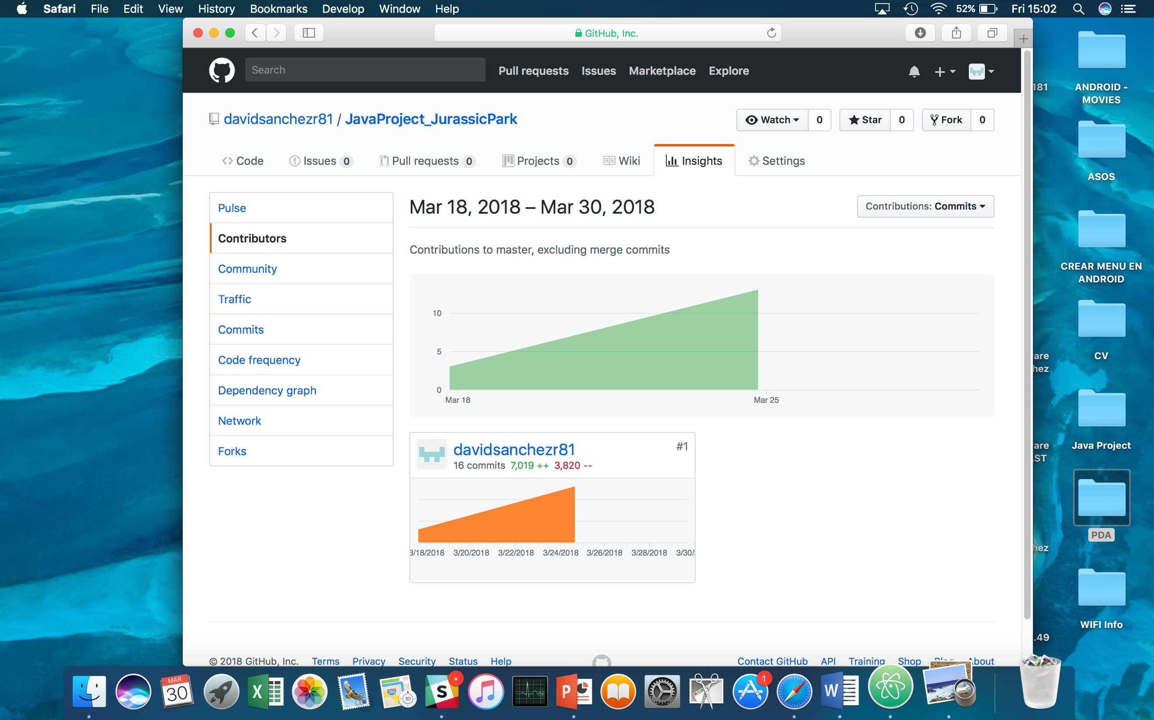Take a screenshot of one of your projects where you have worked alone and attach the Github link.

**Ref:** P12

* Take screenshots or photos of your planning and the different stages of development to show changes.
* *Starting the Java Project using Trello for planning*

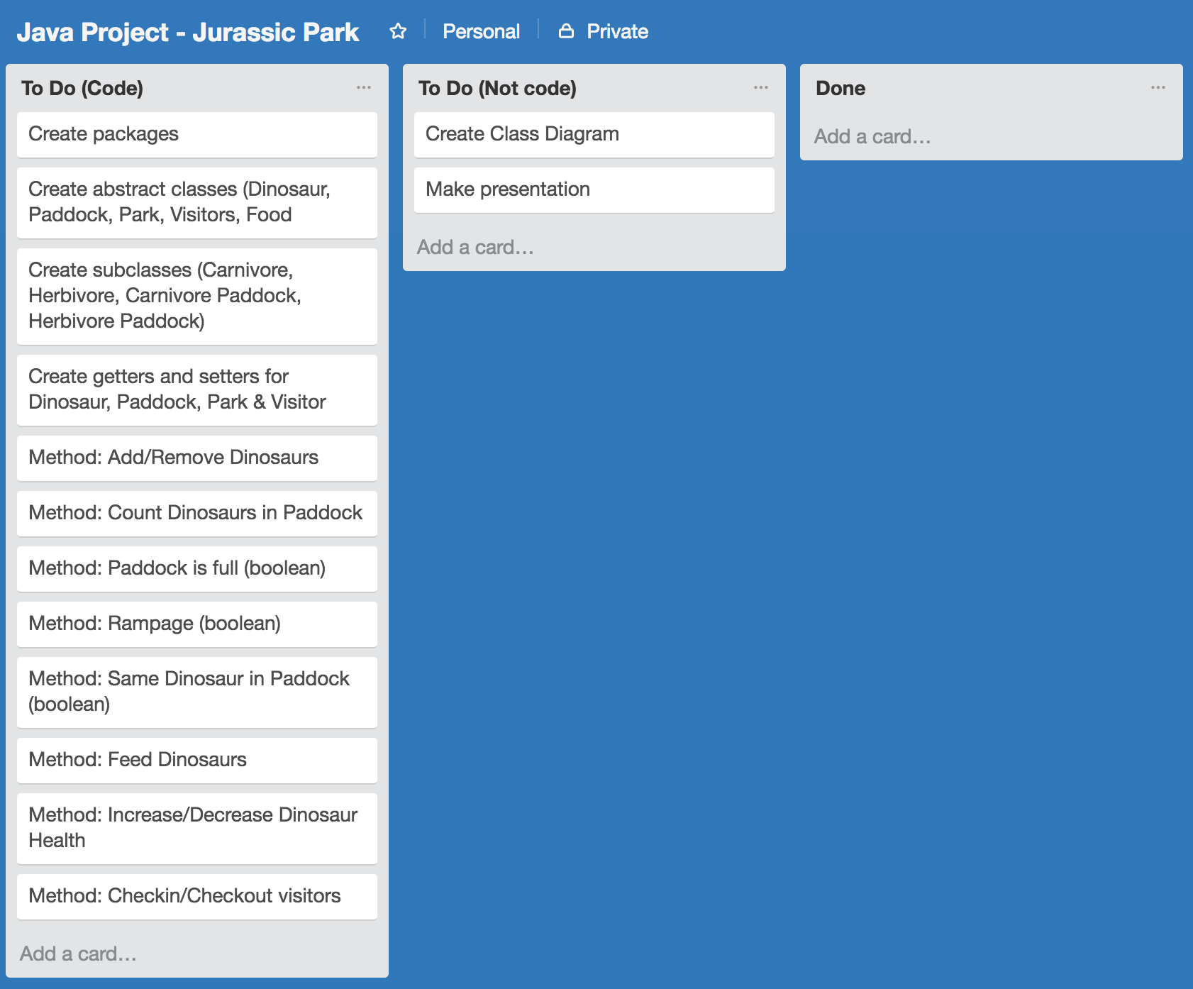

* *Class Diagram of Jurassic Park Project*

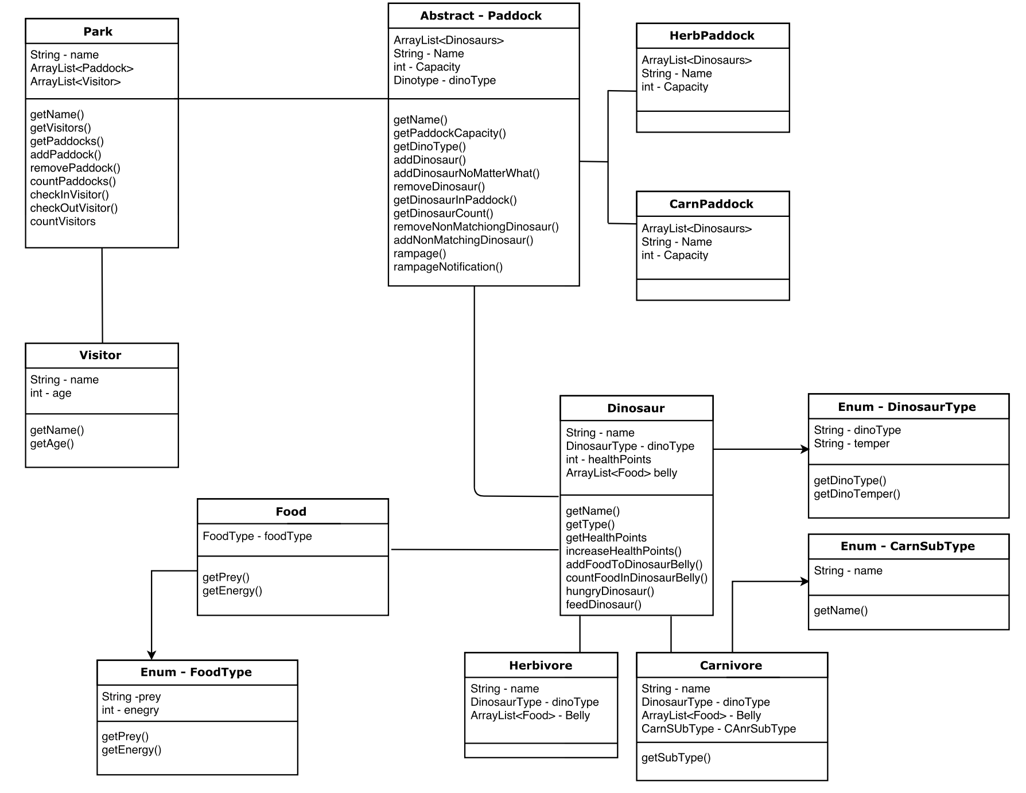

* *50% of the Java Project Completed*

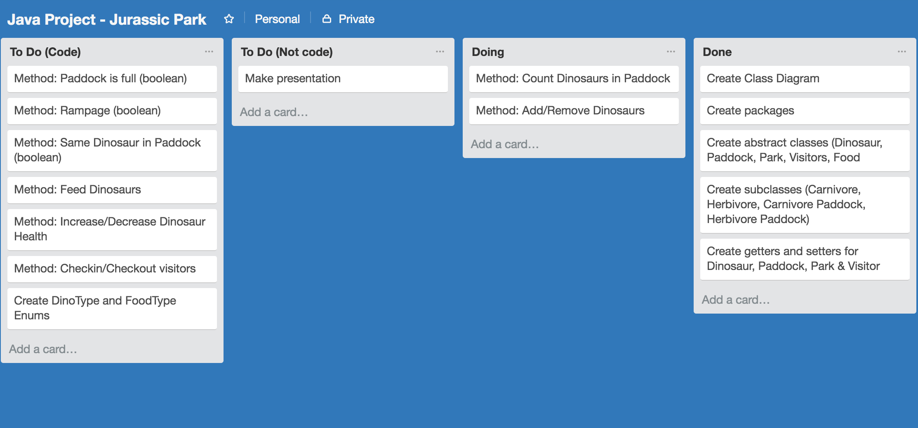

* *100% of the Java Project Completed*

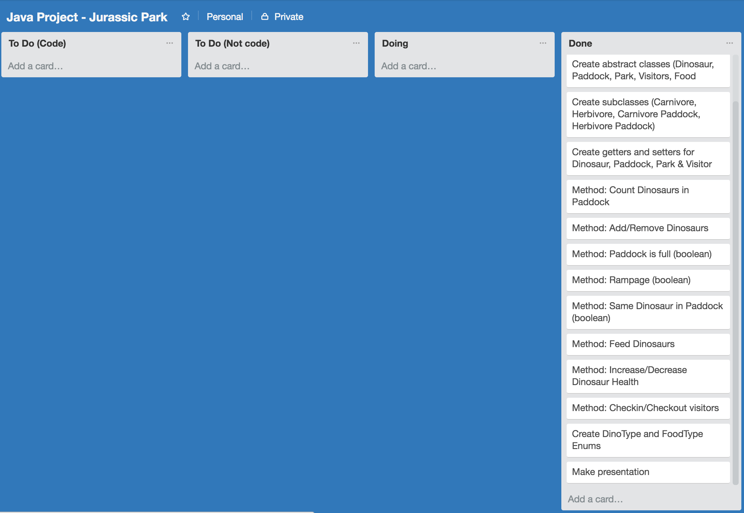

* *PowerPoint presentation*

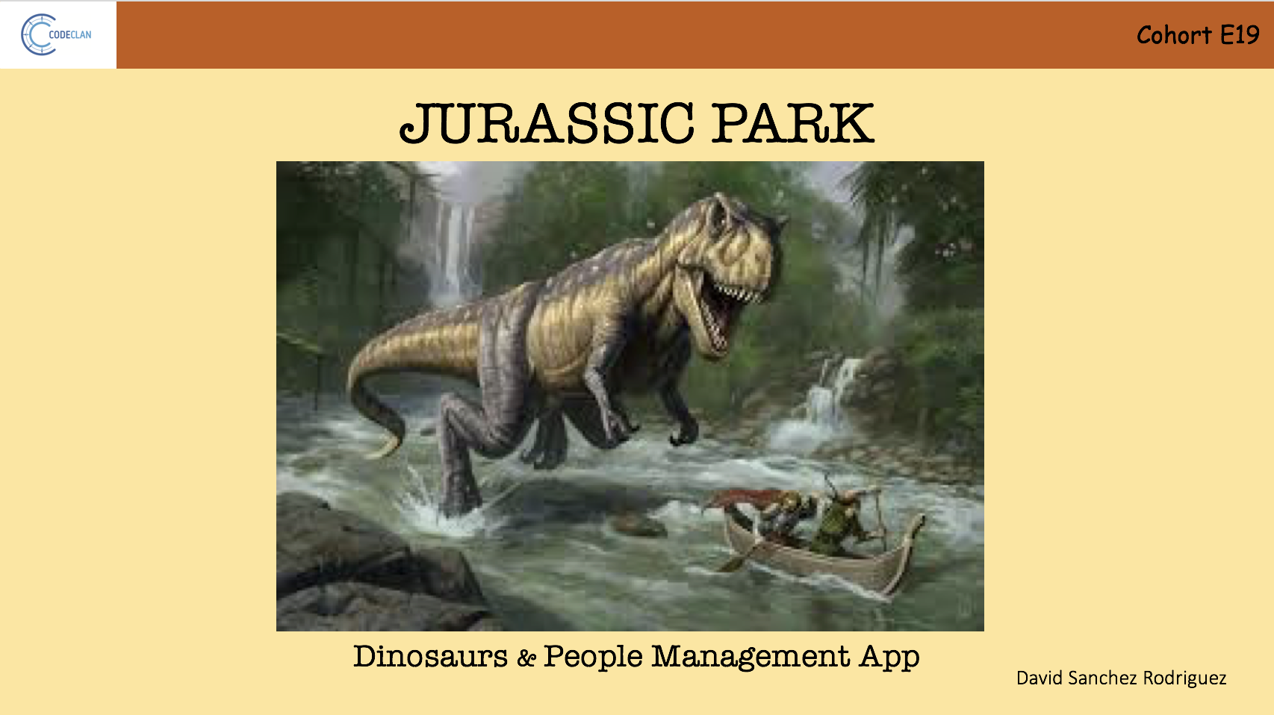

* *Final Java project layout*

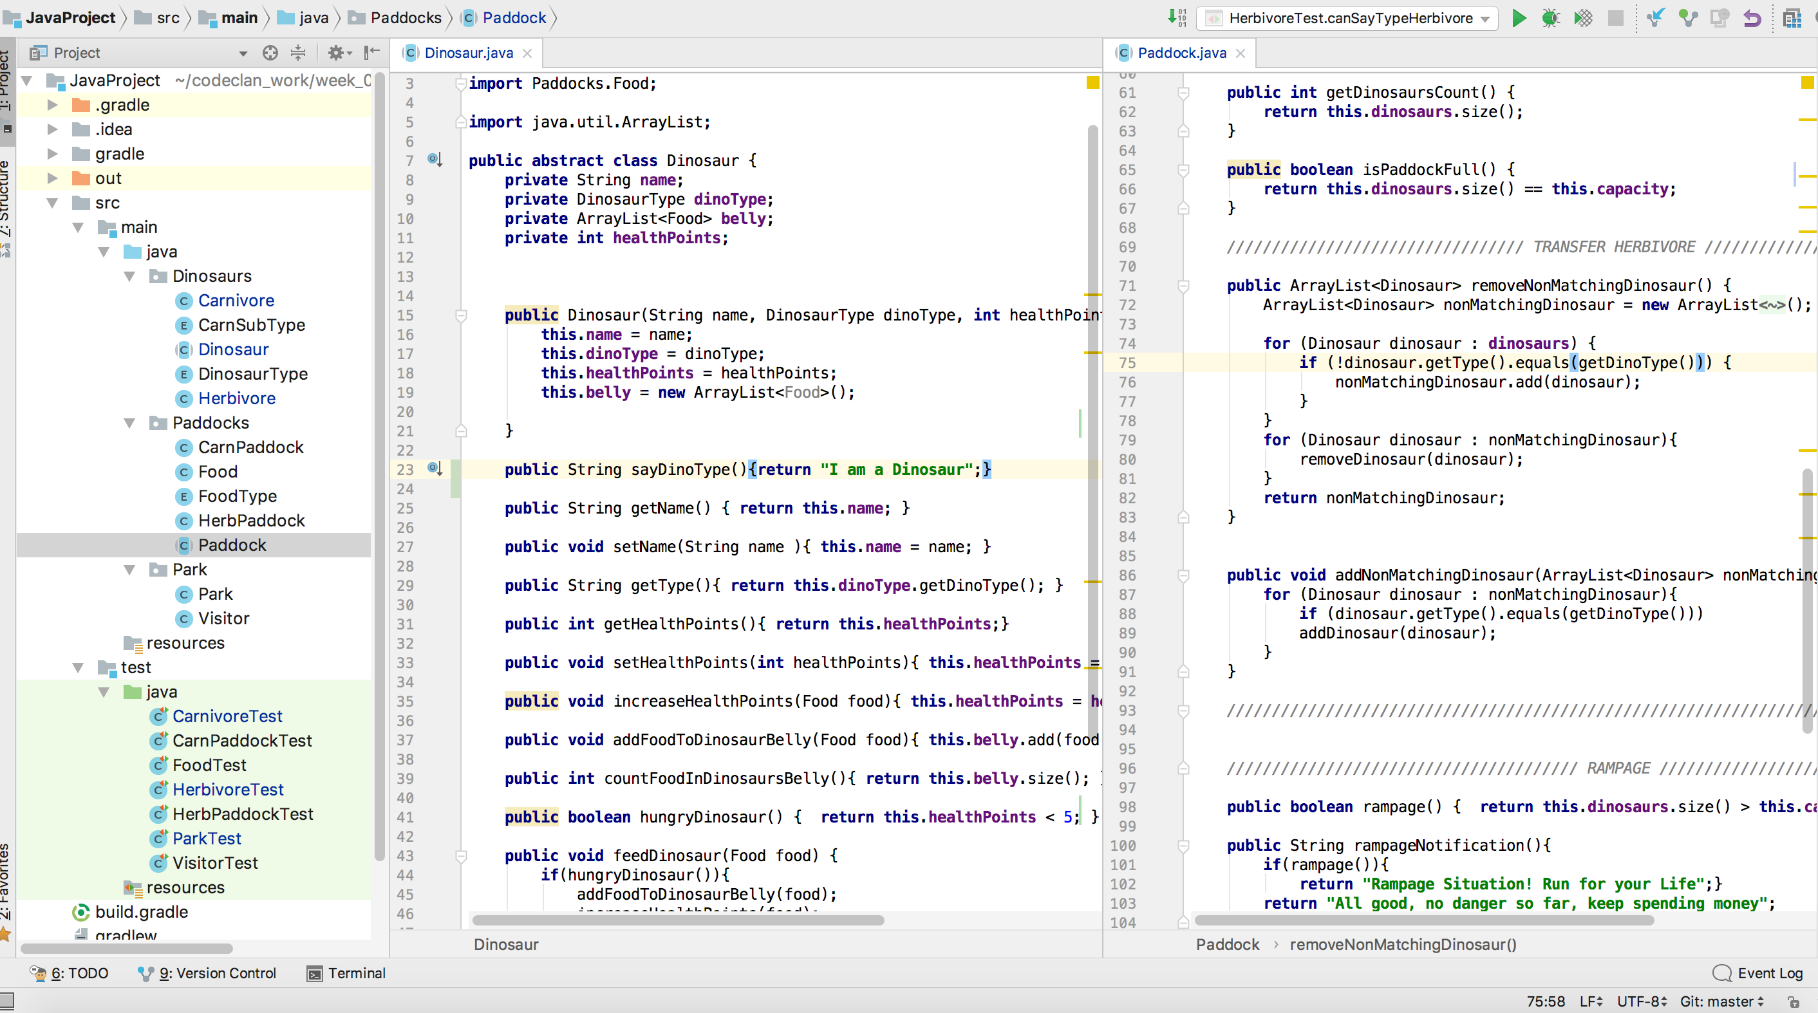

**Ref:** P18

Demonstrate testing in your program. Take screenshots of:

* Example of test code

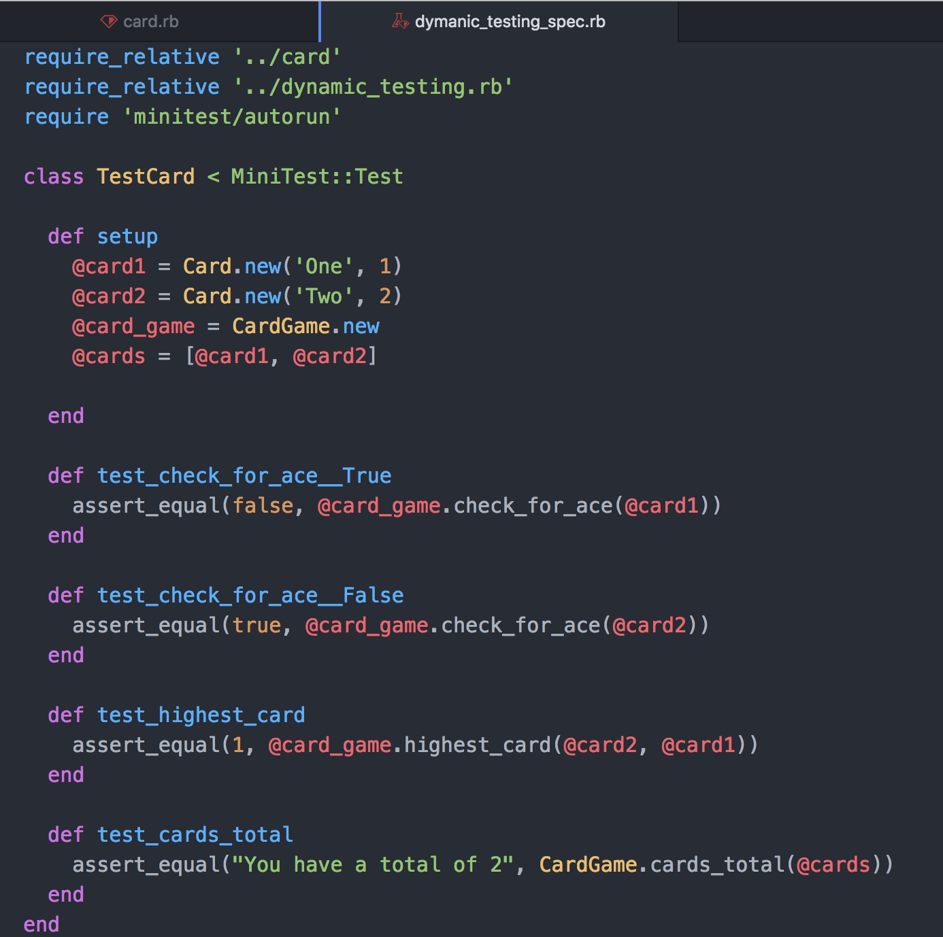

* The test code failing to pass

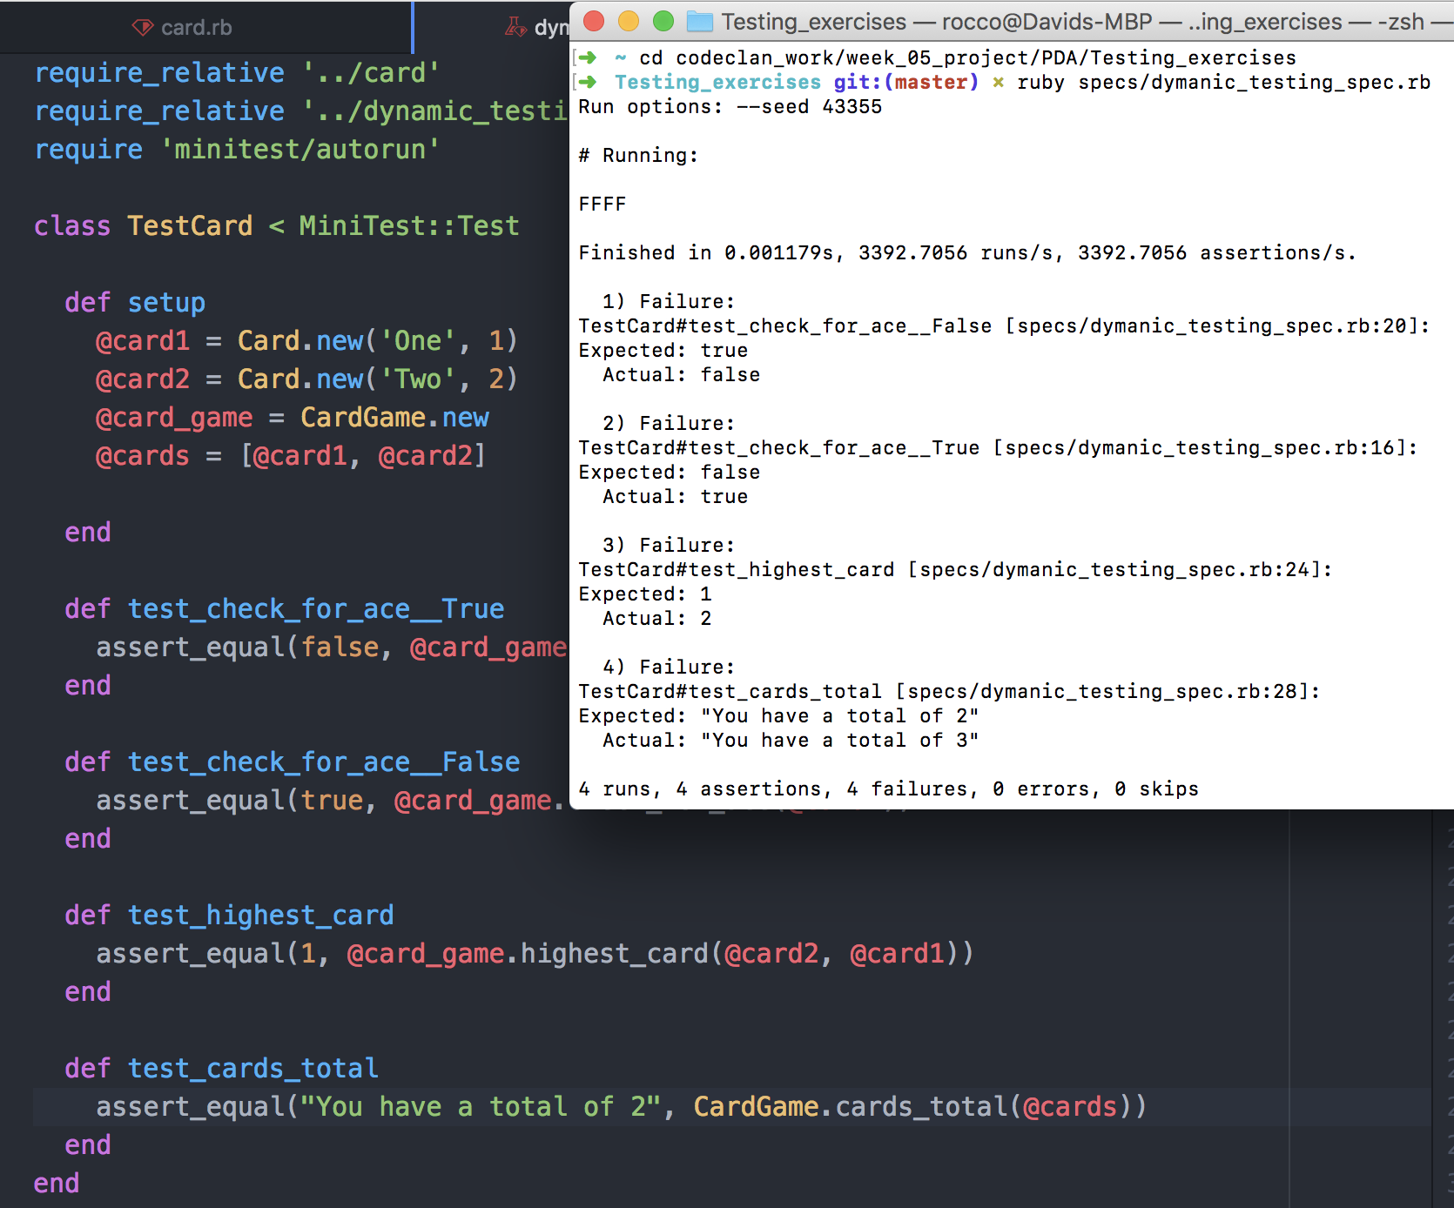

* Example of the test code once errors have been corrected

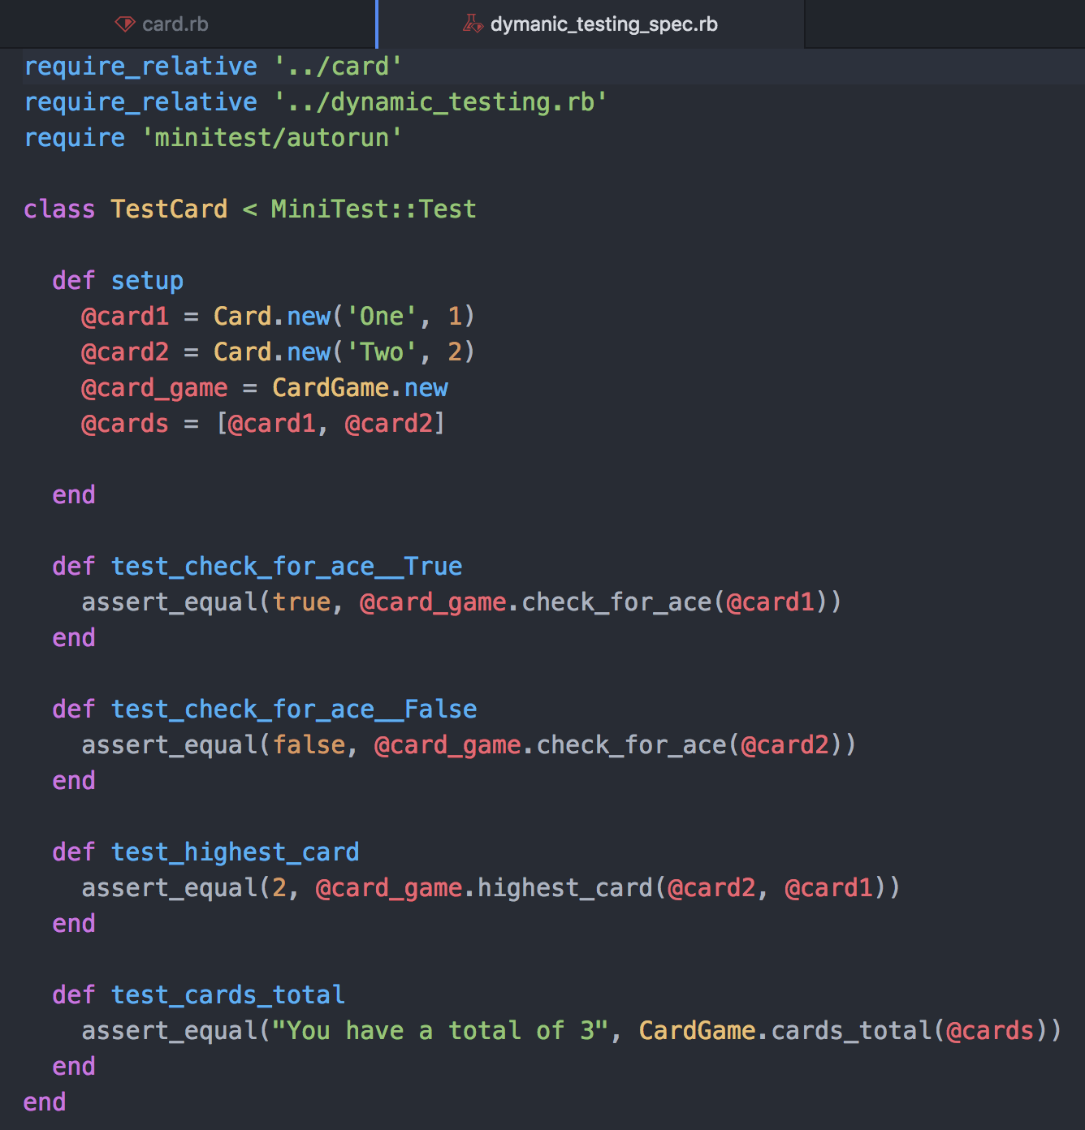

* The test code passing

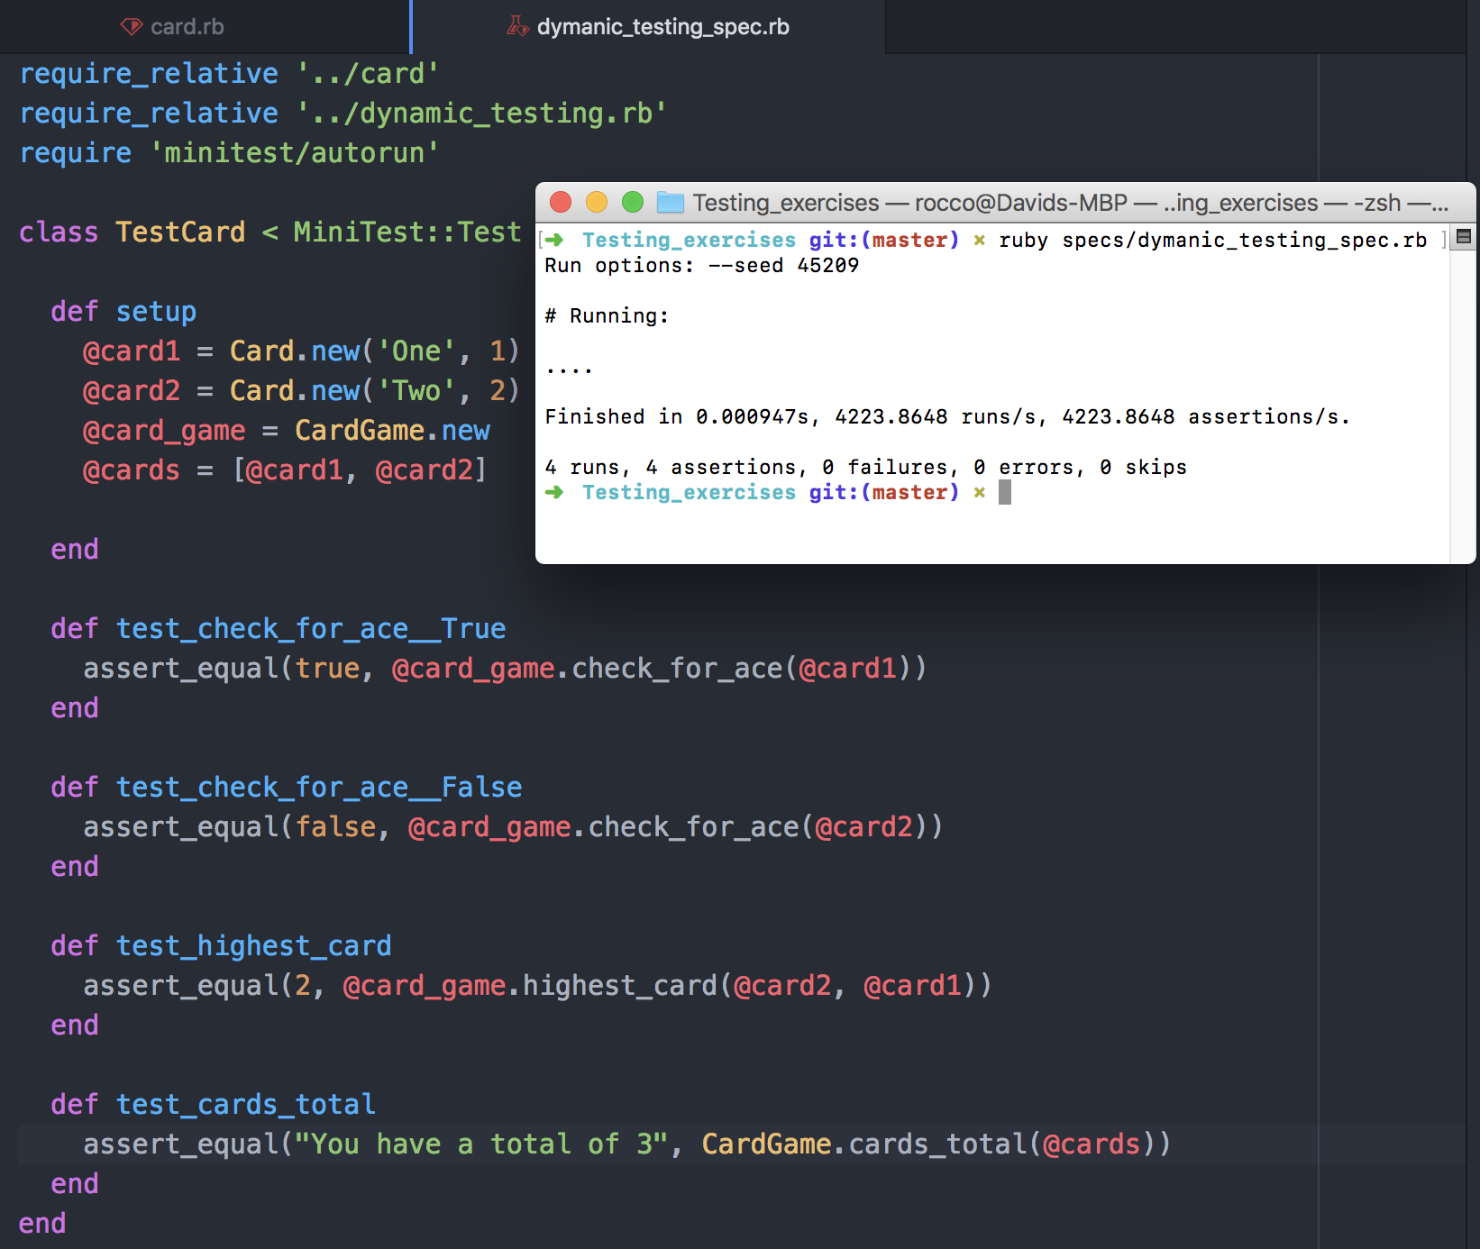

**Ref:** P16

Show an API being used within your program. Take a screenshot of:

* The code that uses or implements the API

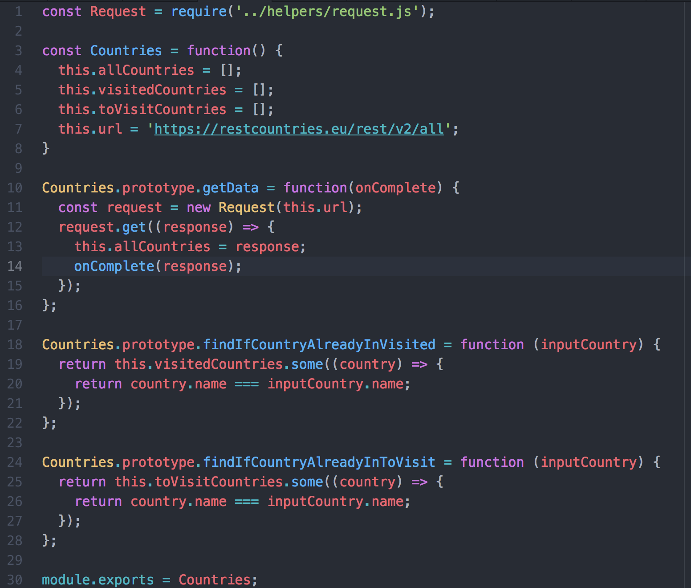

* The API being used by the program whilst running

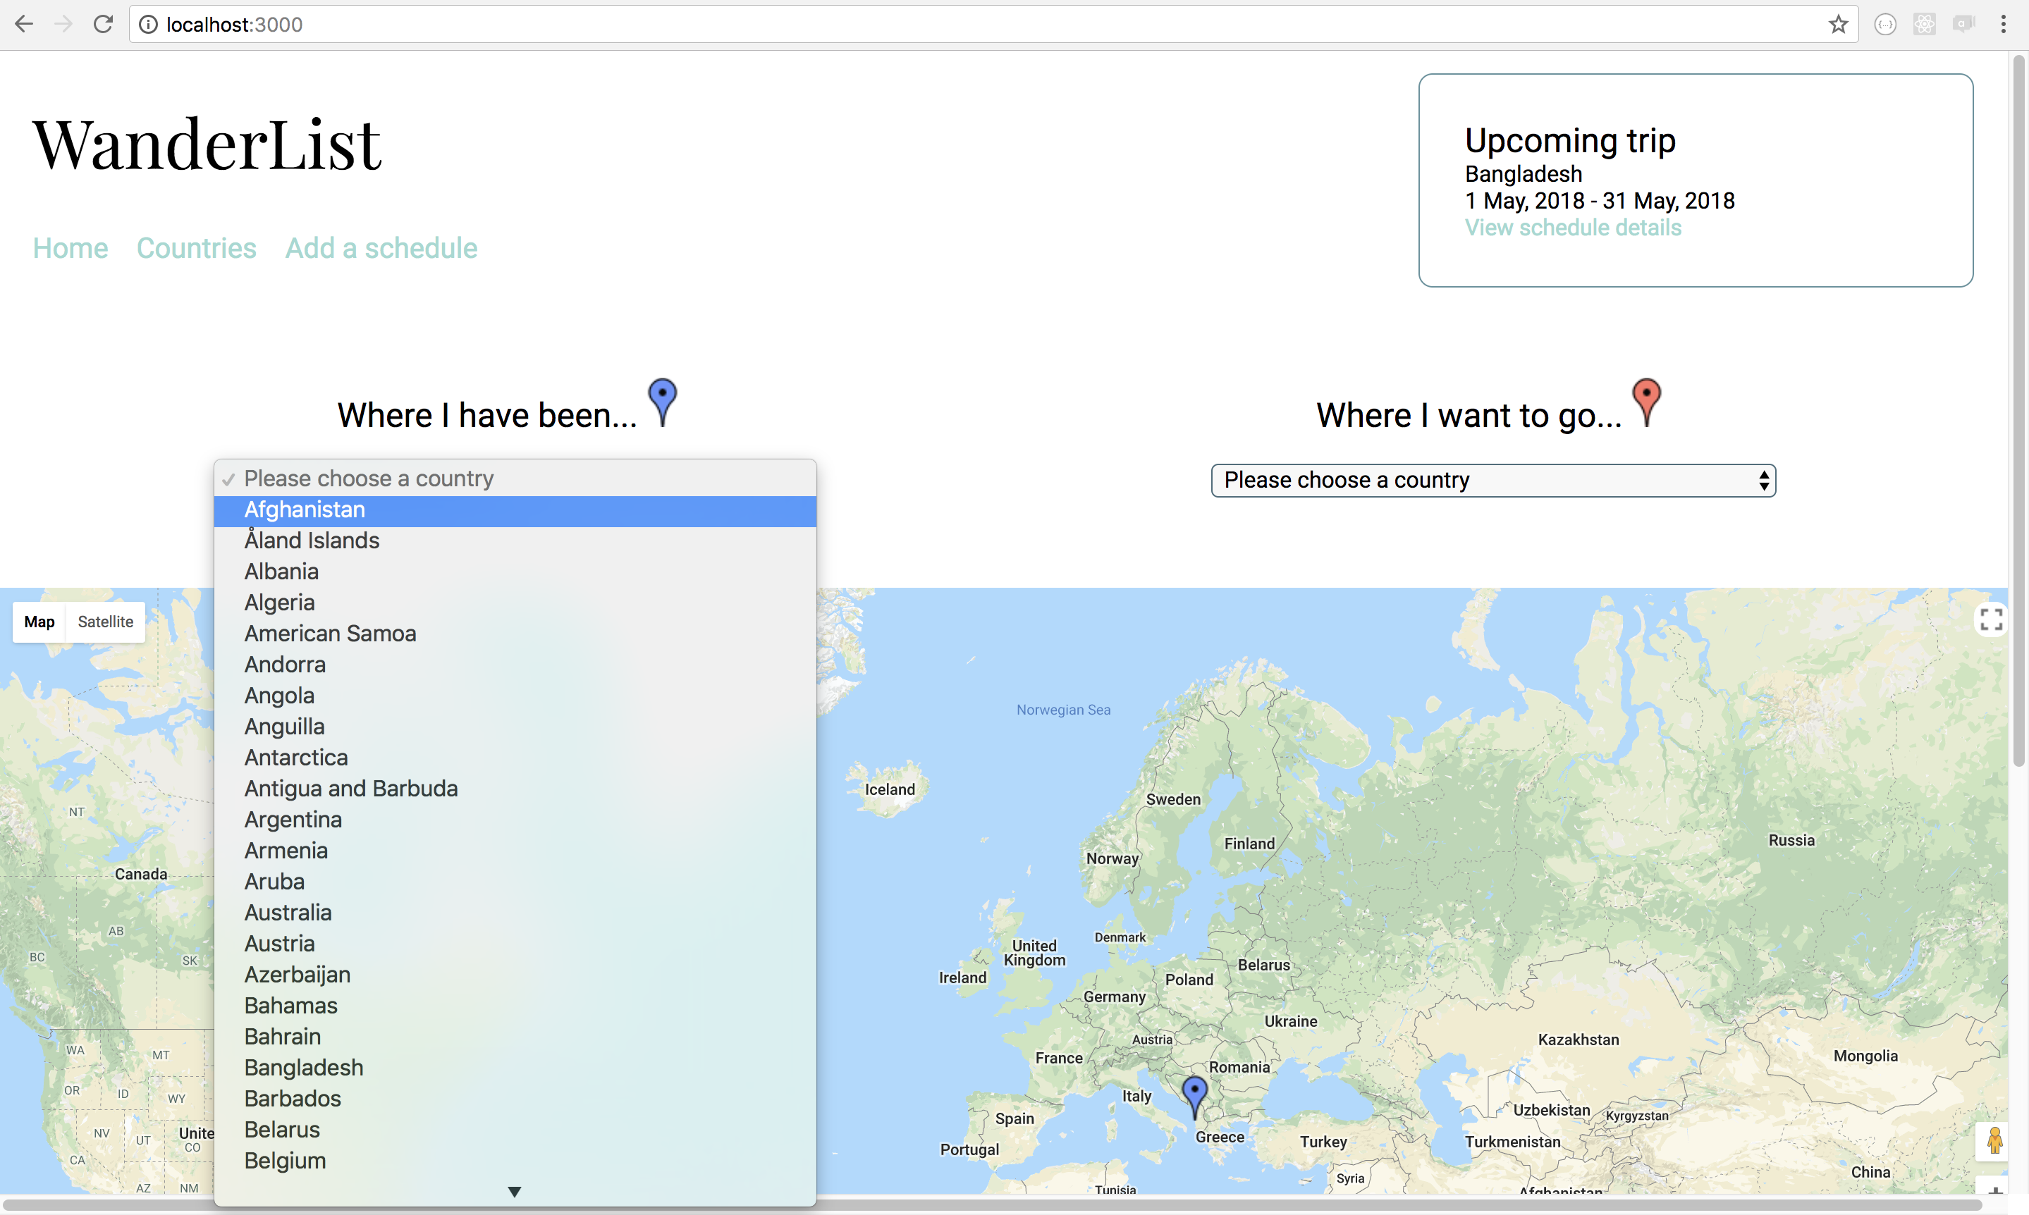

**Ref:** P1

Take a screenshot of the contributor’s page on Github from your group project to show the team you worked with:

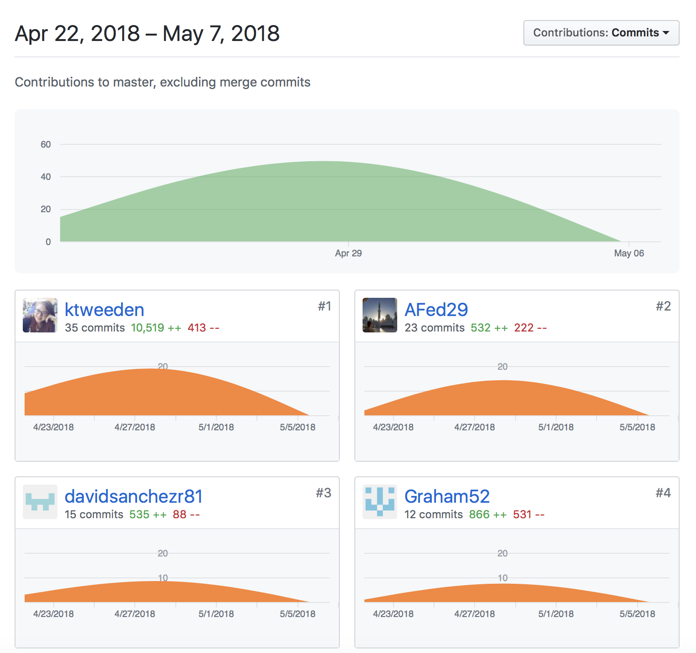

**Ref:** P2

Take a screenshot of the project brief from your grouo project

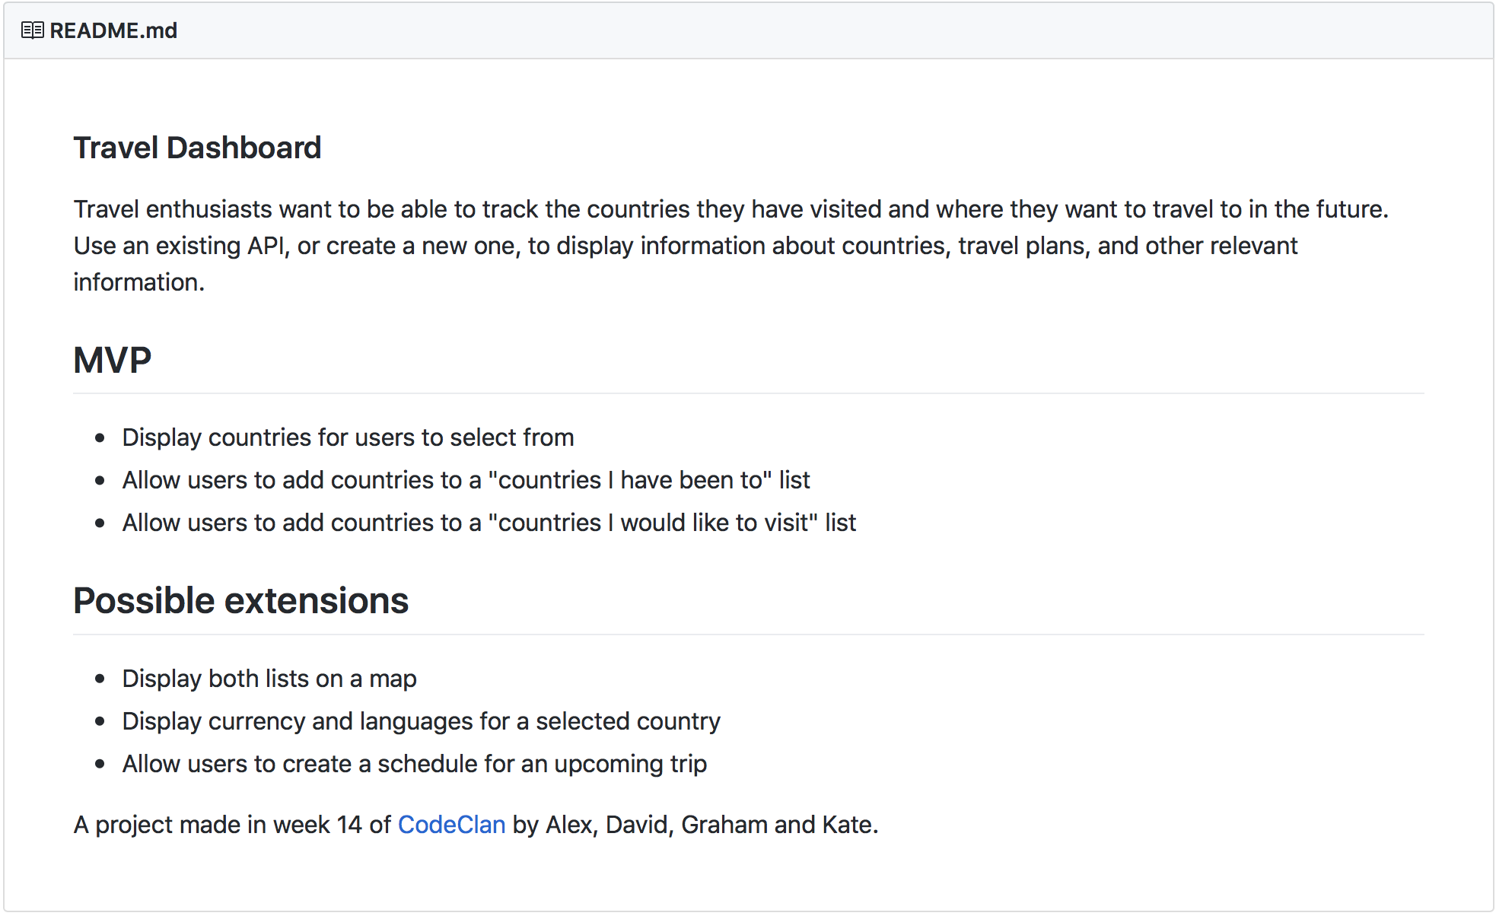

**Ref:** P3

Provide a screenshot of the planning you completed during your group project:

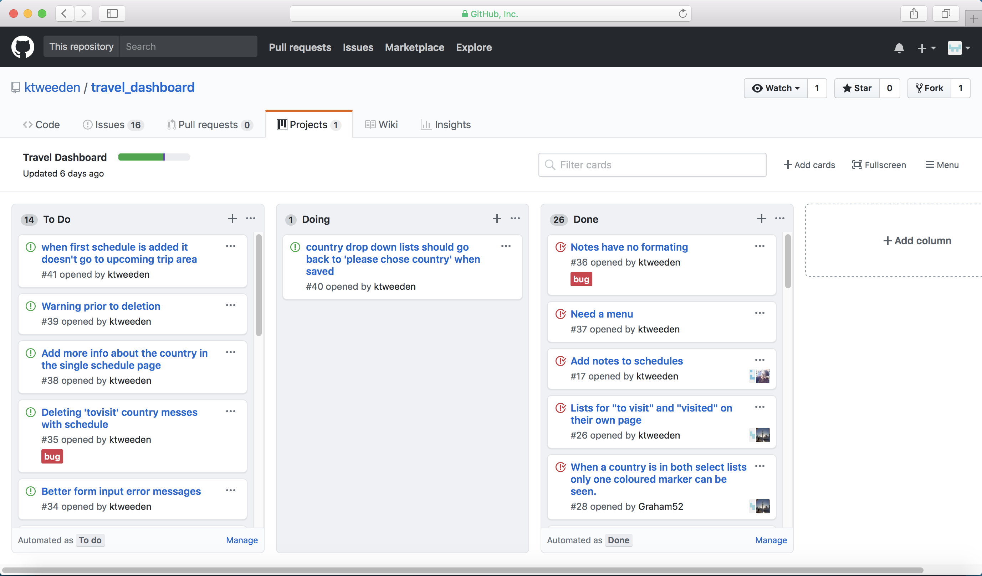

**Ref:** P4

Write an acceptance criteria and test plan.



**Ref:** P7

Produce two system interaction diagrams:

* Sequence diagram

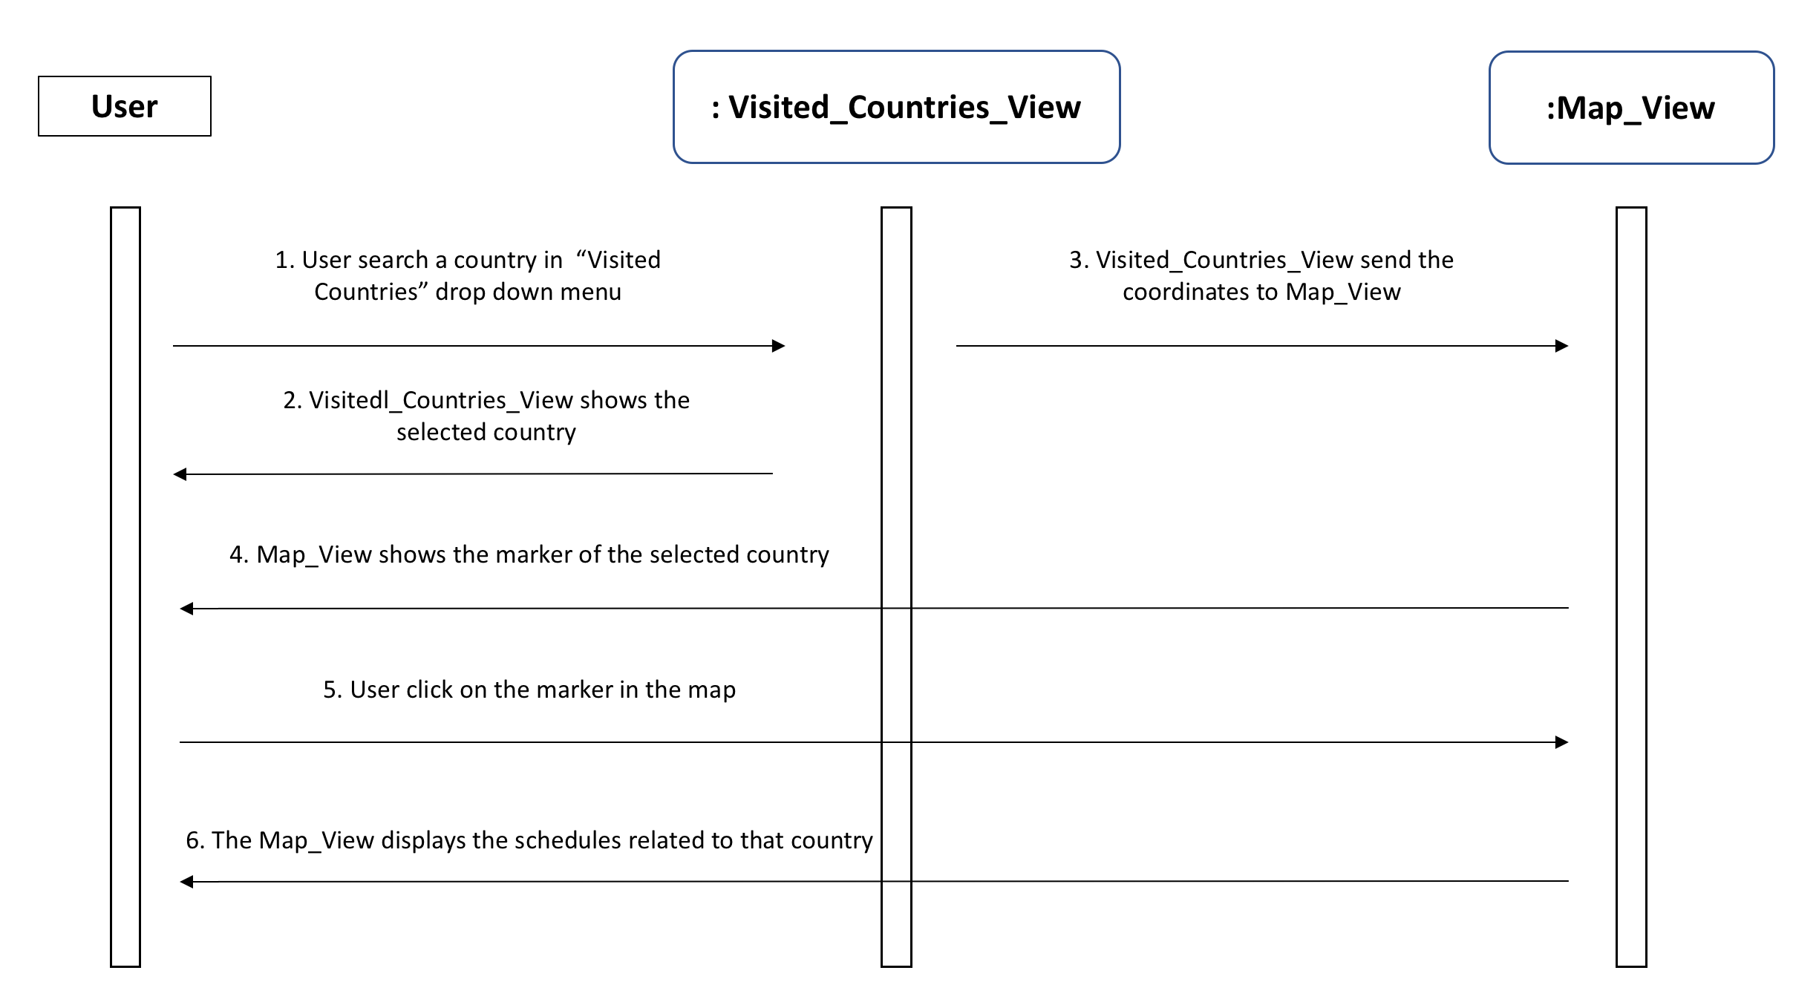

* Collaboration diagram

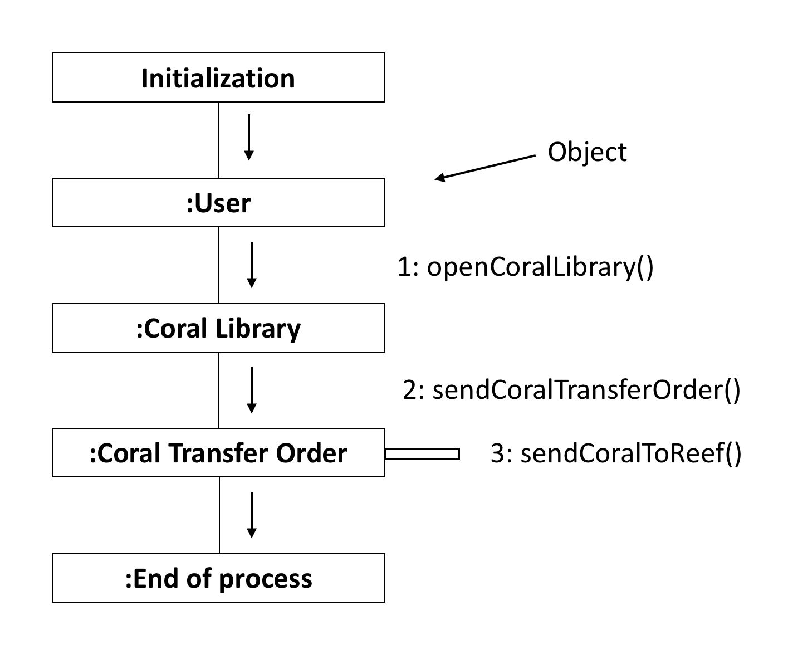

**Ref:** P8

Produce two object diagrams.

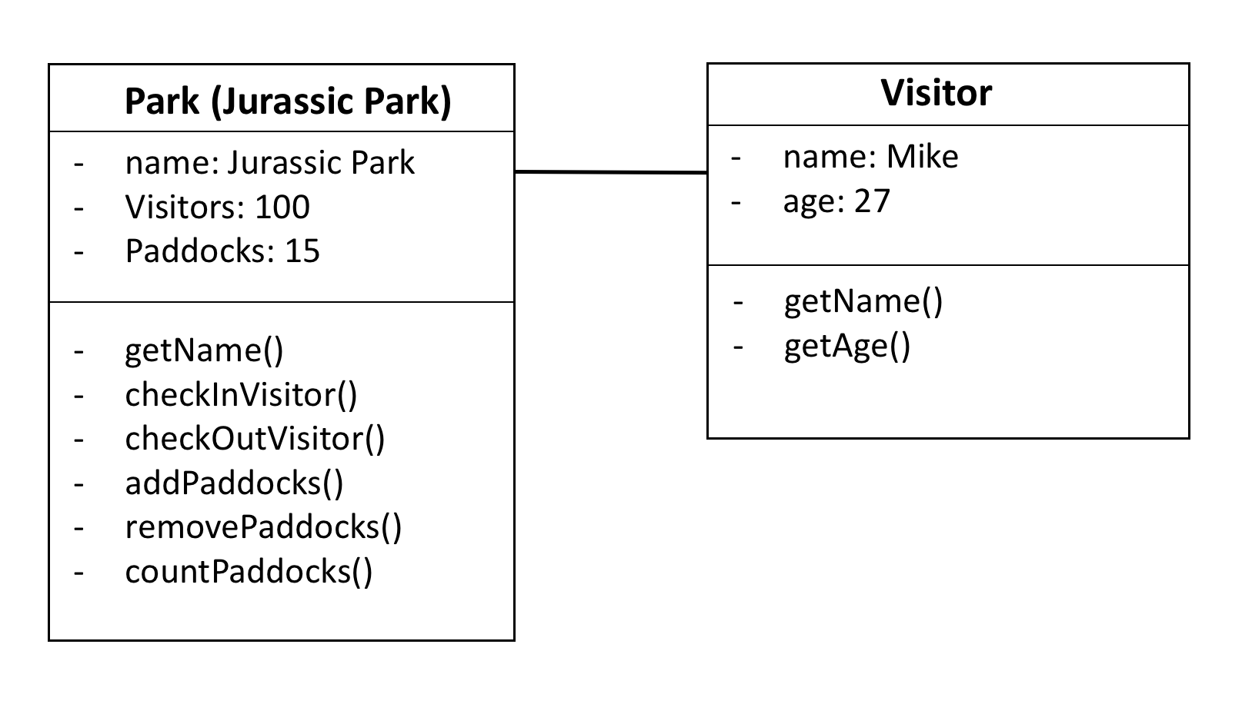

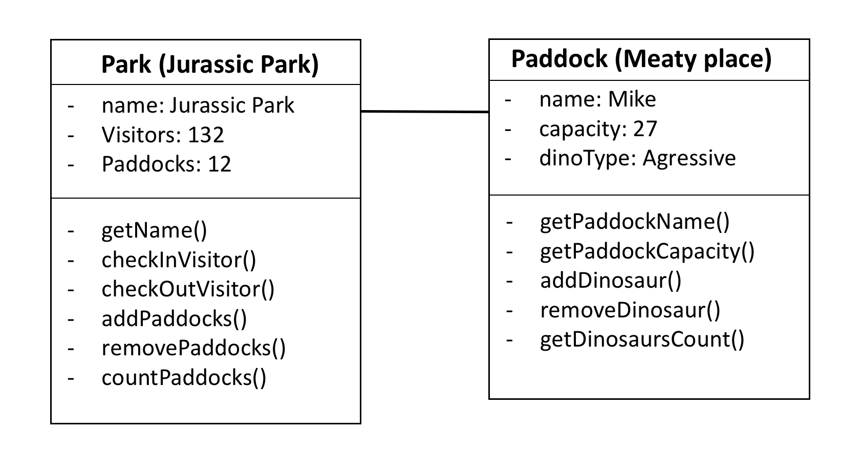

**Ref:** P9

Select two algorithms you have written (NOT the group project). Take a screenshot of each and write a short statement on why you have chosen to use those algorithms.

1. **feedDinosaur()**

The reason this method was chosen is because the dinosaurs needed to be fed. However, this method is composed by 3 different methods ( hungryDinosaur(), addFoodToDinosaurBelly(), increaseHealthPoints() ).

The first method *hungryDinosaur()* would check if the animal is hungry giving a true or false result based on the current health level of the dinosaur. Therefore, if the animal is hungry the second method *addFoodToDinosaurBelly()* would run and the number of units of food eaten would be added to the belly. Finally, the method *increaseHealthPoints()* would increase the health level of the animal. Each food eaten would have a different health value.

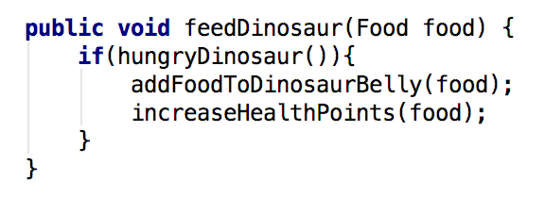

1. **removeNonMatchingDinosaur()**

The reason this method was chosen is because it was necessary to remove those dinosaurs of a different type from the paddock under evaluation.

First of all, an array for those dinosaurs to be removed from the paddock is created, *nonMatchingDinosaur*.

The first for loop would take those different dinosaurs from the paddock and would add them to the array previously created.

The second for loop would remove form the paddock the dinosaurs added to the array.

This method will return the array.

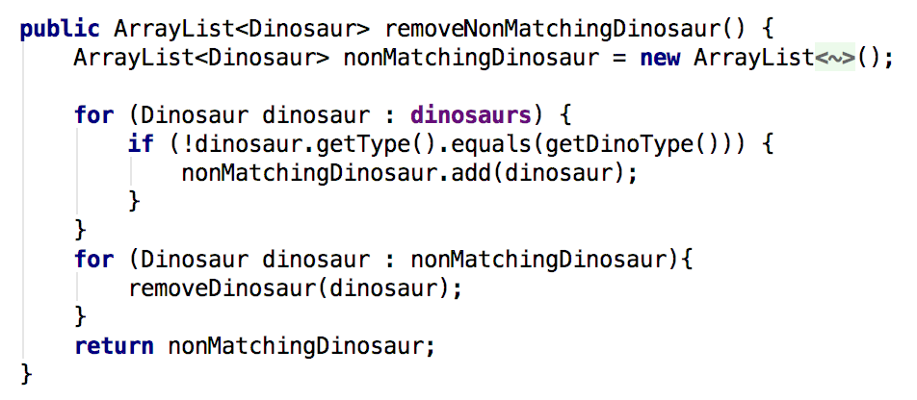

**Ref:** P17

Produce a bug tracking report

